Appendix

# Concentration time profiles

## 1) Setting Up the Project and Basic Simulations

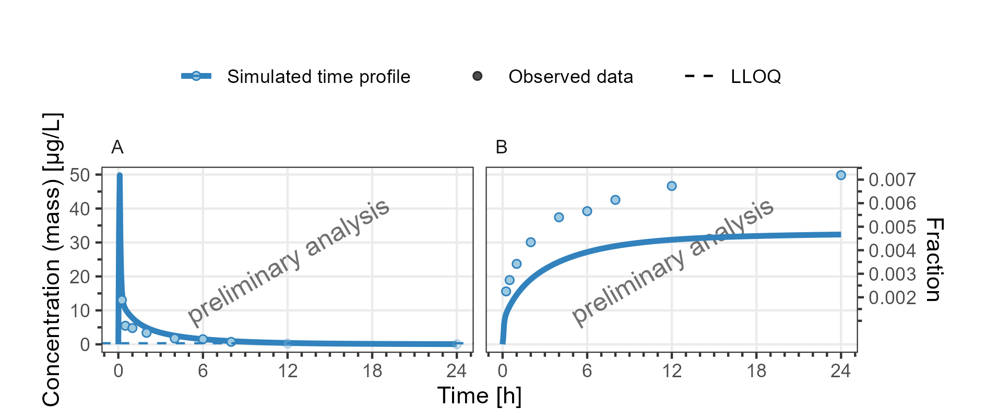

**Figure 1: Concentration-time profiles for DrugX Plasma (A) and Fraction excreted to urine (B) for individual 1 of study 000 on a linear y-scale. DrugX was admistered as a 1mg Iv application with an infusion time of 5 minutes.**

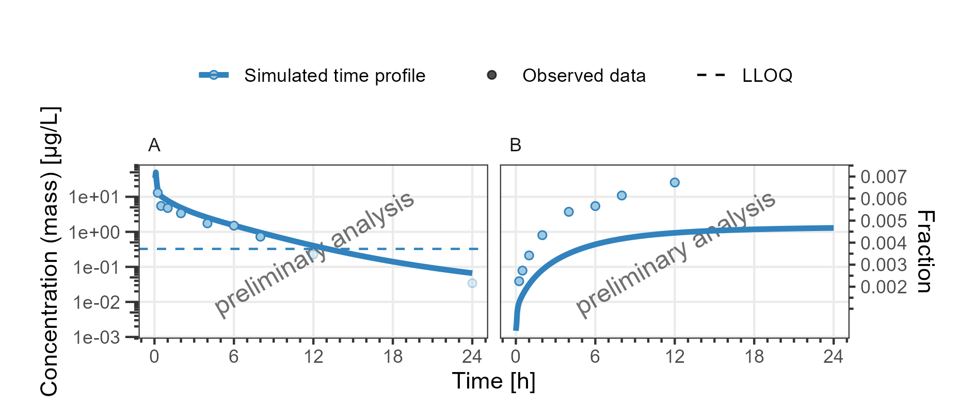

**Figure 2: Concentration-time profiles for DrugX Plasma (A) and Fraction excreted to urine (B) for individual 1 of study 000 on a logarithmic y-scale. DrugX was admistered as a 1mg Iv application with an infusion time of 5 minutes.**

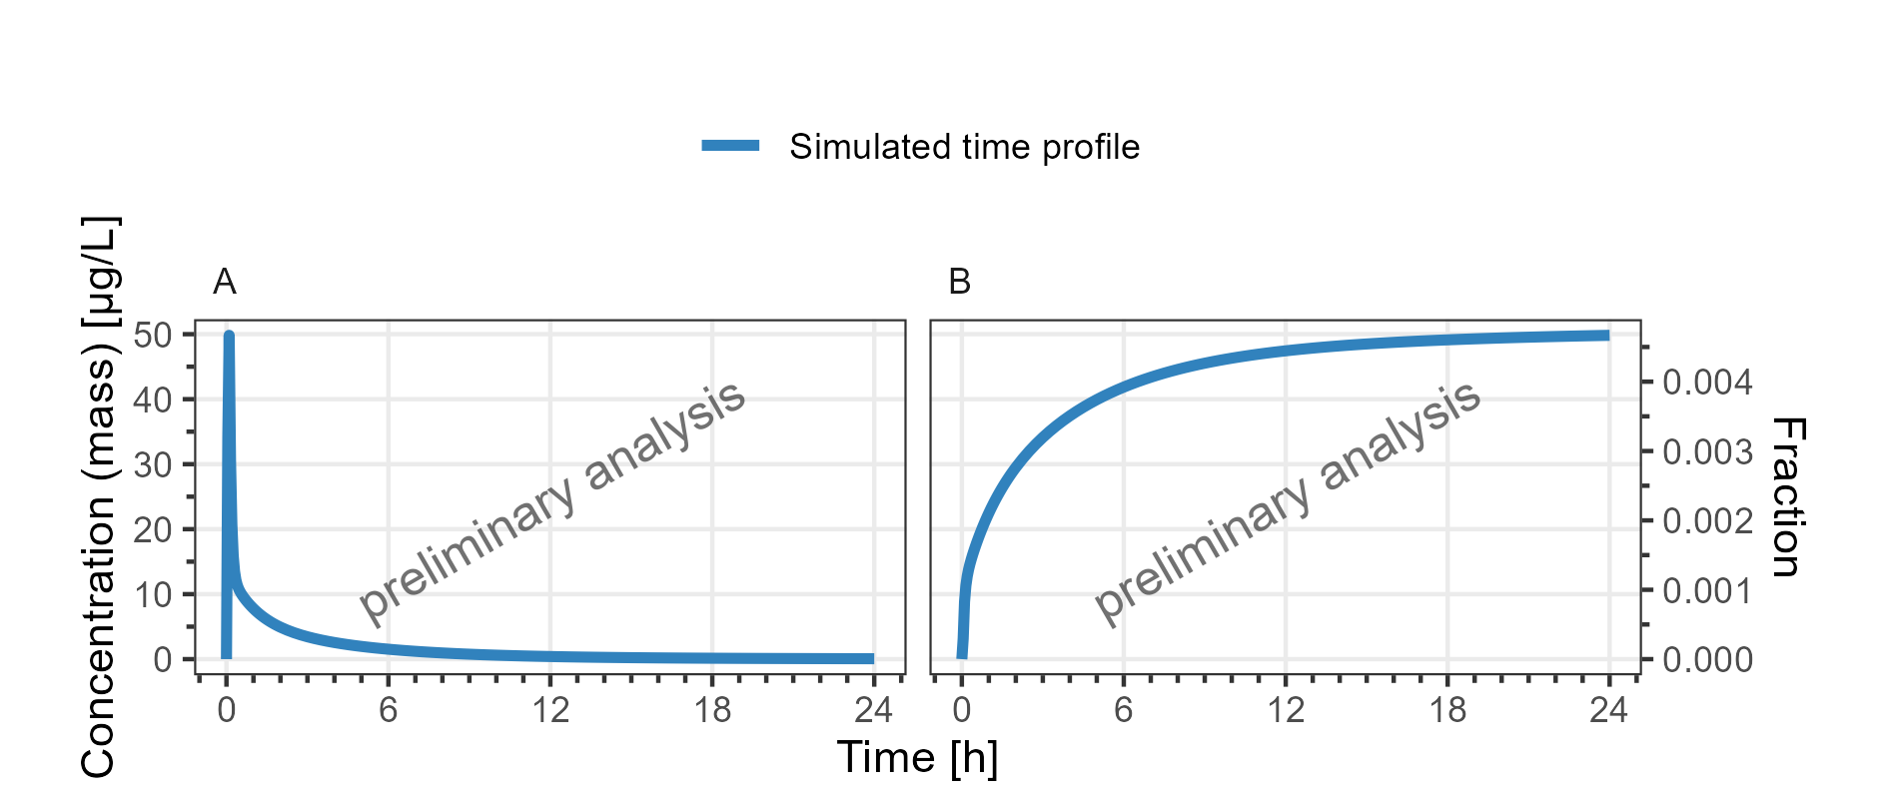

**Figure 3: Concentration-time profiles for DrugX Plasma (A) and Fraction excreted to urine (B) for individual 1 of study 000 on a linear y-scale. DrugX was admistered as a 1mg Iv application with an infusion time of 5 minutes.**

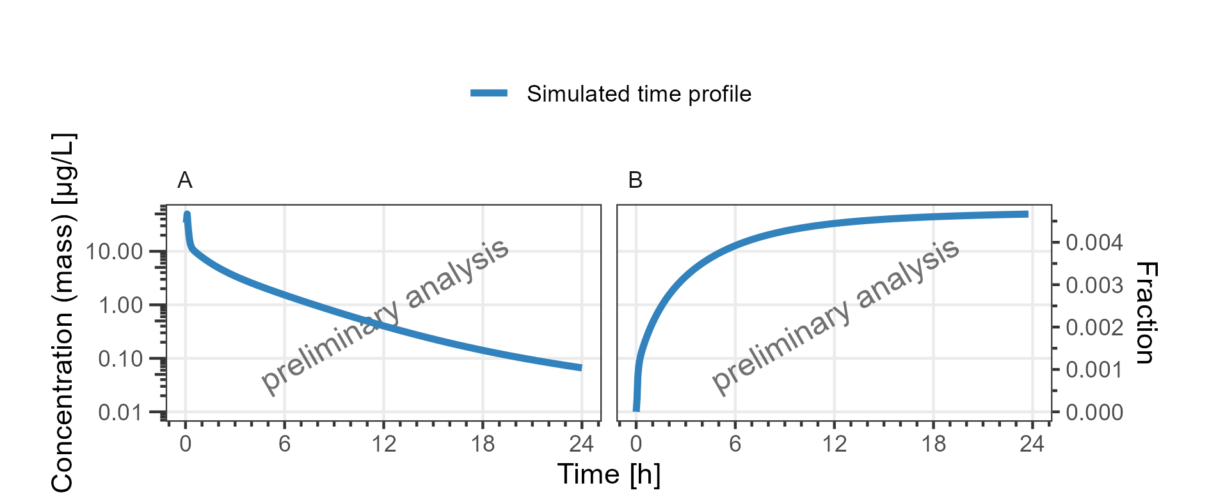

**Figure 4: Concentration-time profiles for DrugX Plasma (A) and Fraction excreted to urine (B) for individual 1 of study 000 on a logarithmic y-scale. DrugX was admistered as a 1mg Iv application with an infusion time of 5 minutes.**

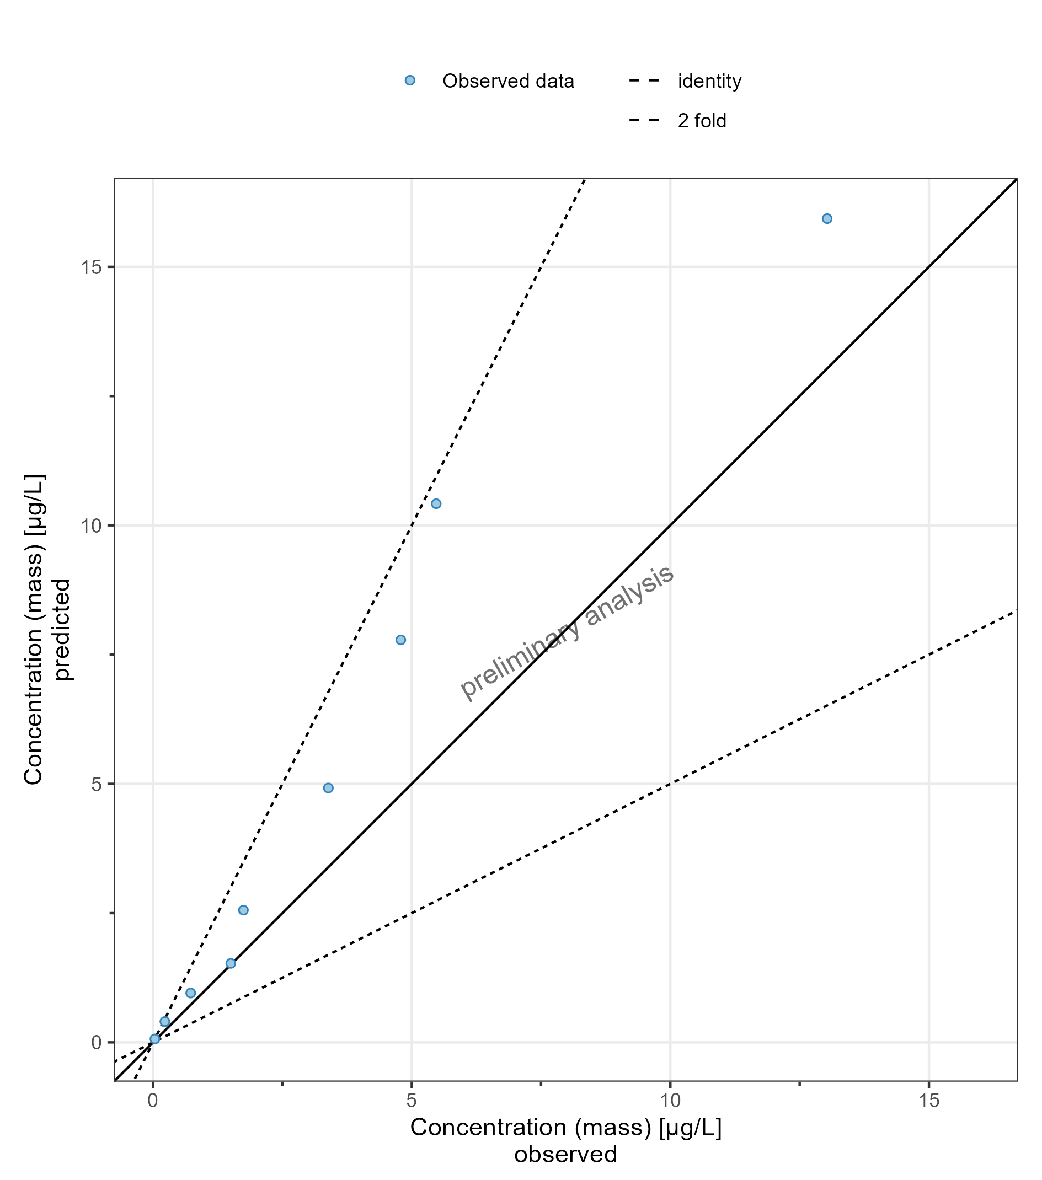

**Figure 5: Predicted vs Observed for DrugX Plasma for individual 1 of study 000 on a linear y-scale. DrugX was admistered as a 1mg Iv application with an infusion time of 5 minutes.**

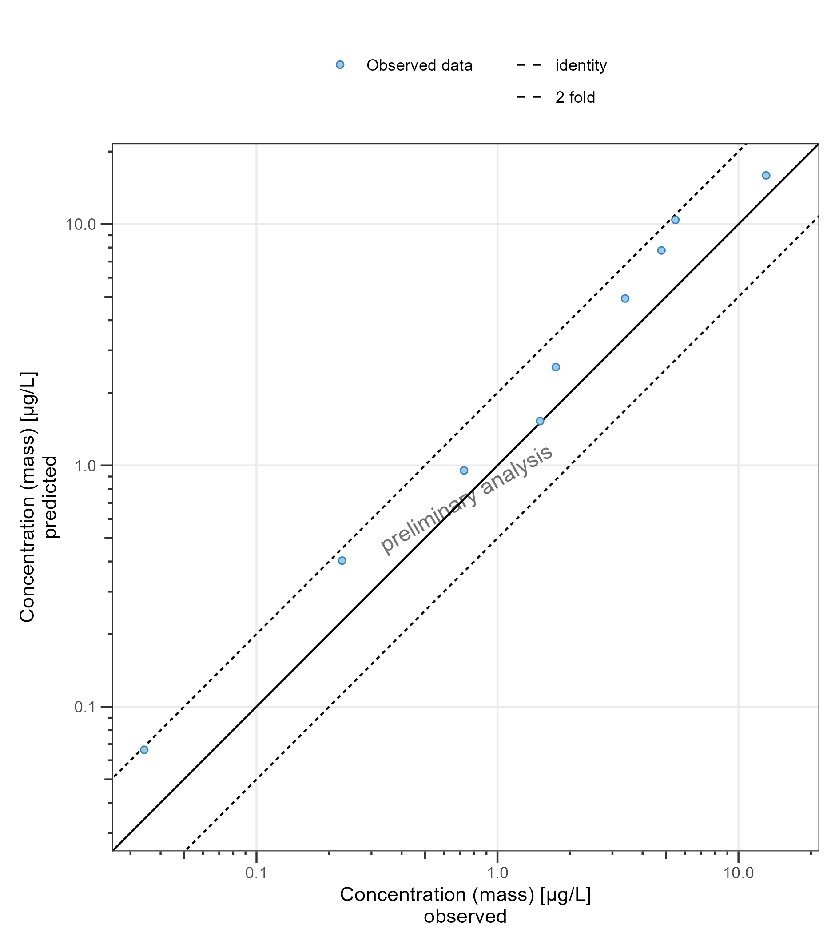

**Figure 6: Predicted vs Observed for DrugX Plasma for individual 1 of study 000 on a logarithmic y-scale. DrugX was admistered as a 1mg Iv application with an infusion time of 5 minutes.**

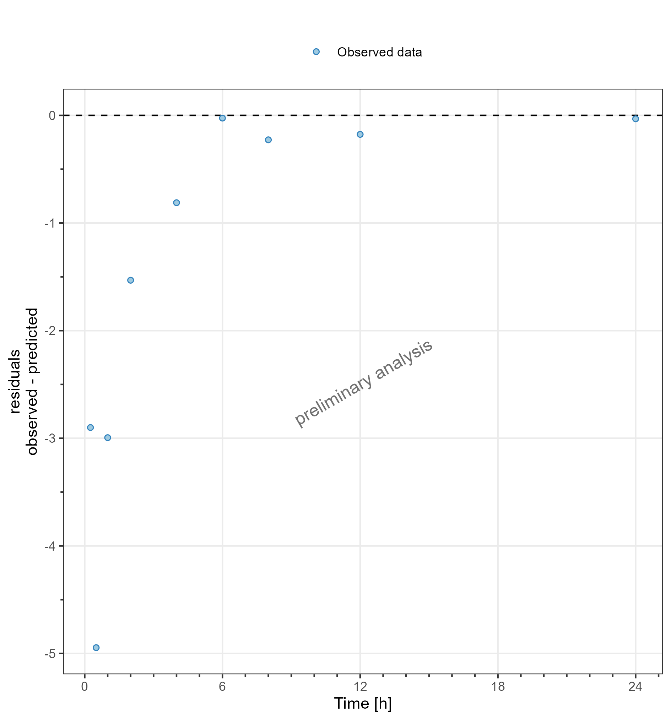

**Figure 7: Residuals vs time values for DrugX Plasma for individual 1 of study 000 on a linear y-scale. DrugX was admistered as a 1mg Iv application with an infusion time of 5 minutes.**

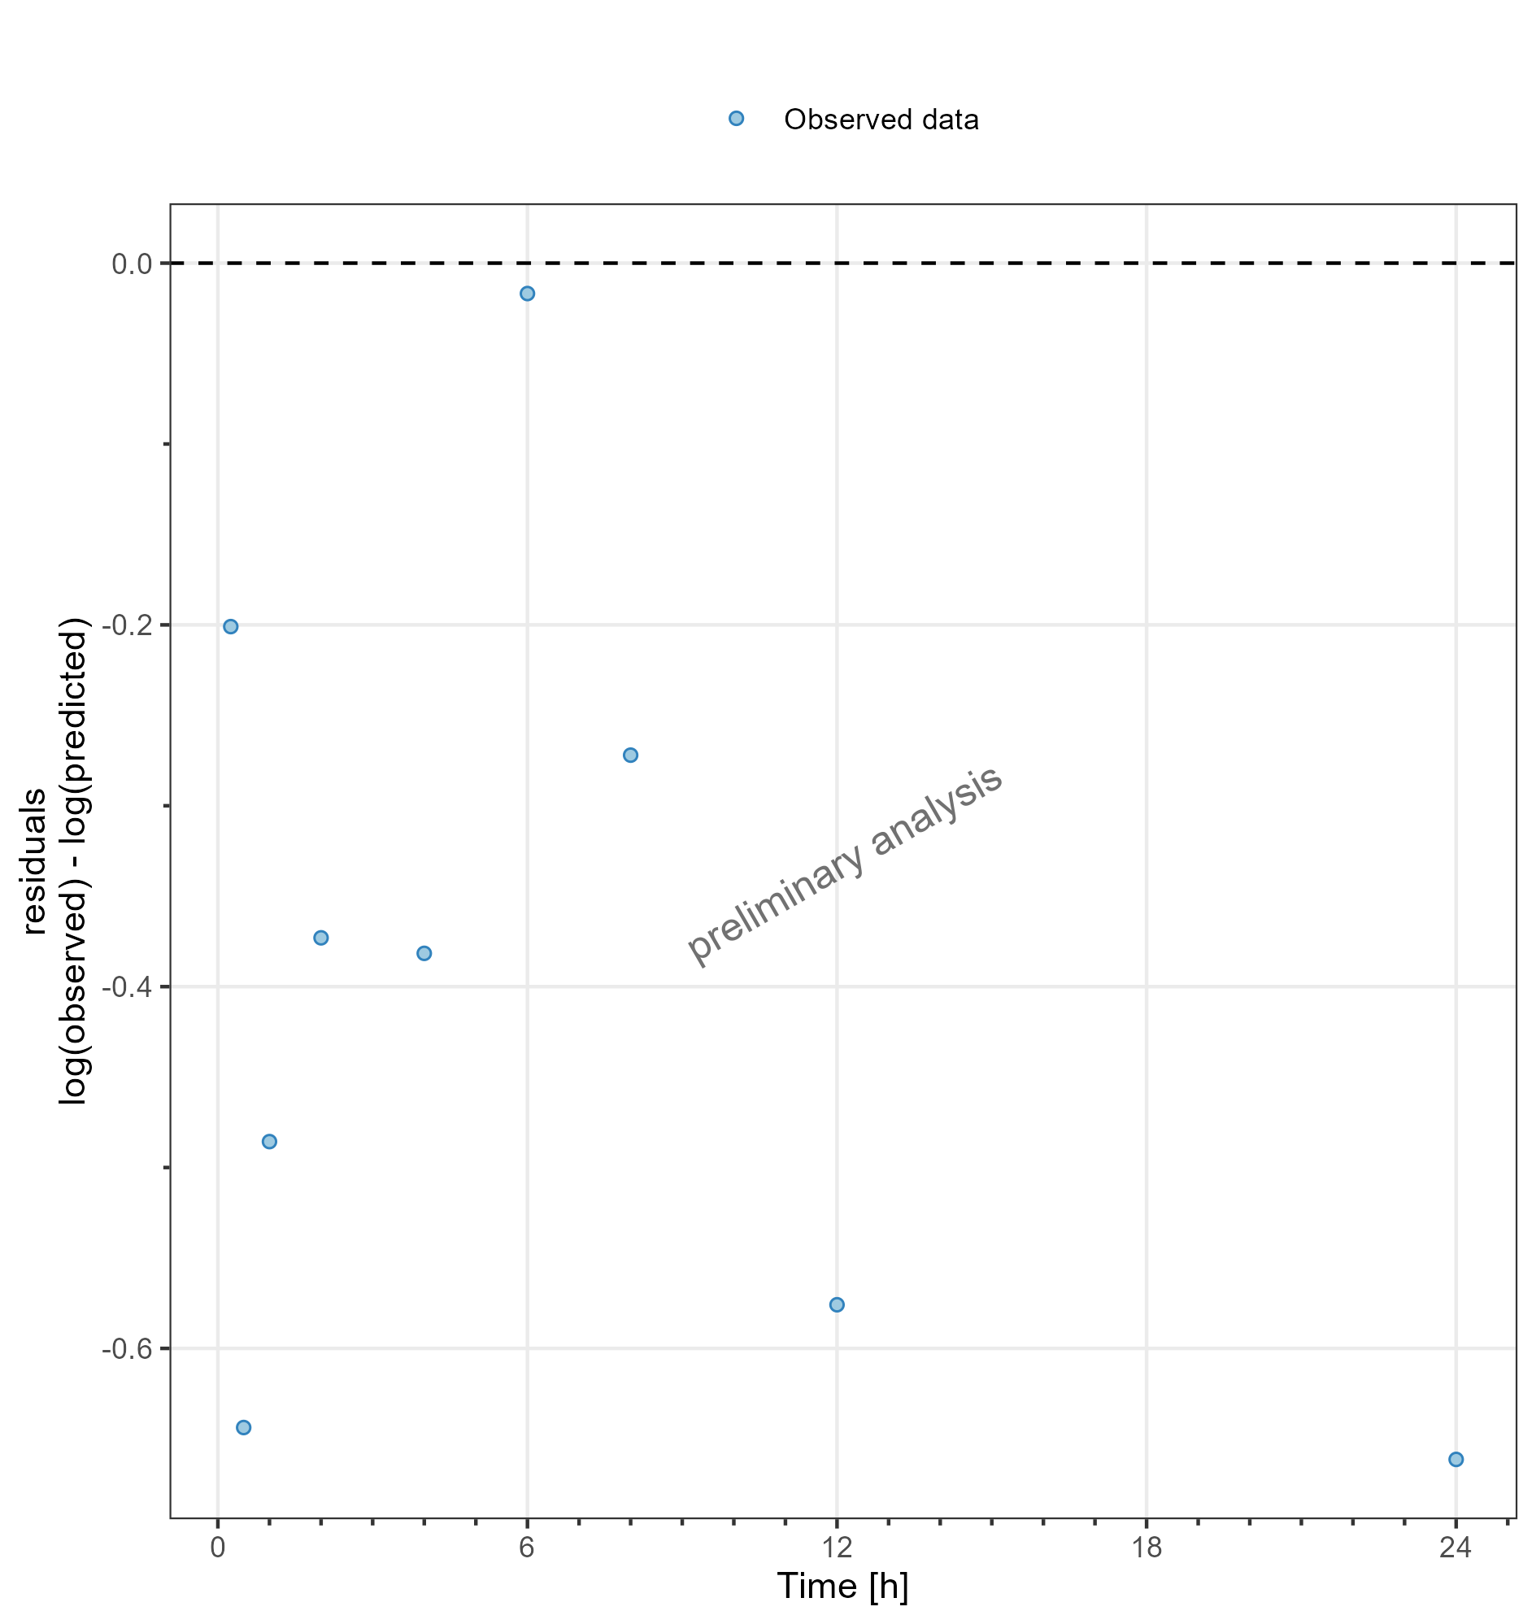

**Figure 8: Residuals vs time values for DrugX Plasma for individual 1 of study 000 on a logarithmic y-scale. DrugX was admistered as a 1mg Iv application with an infusion time of 5 minutes.**

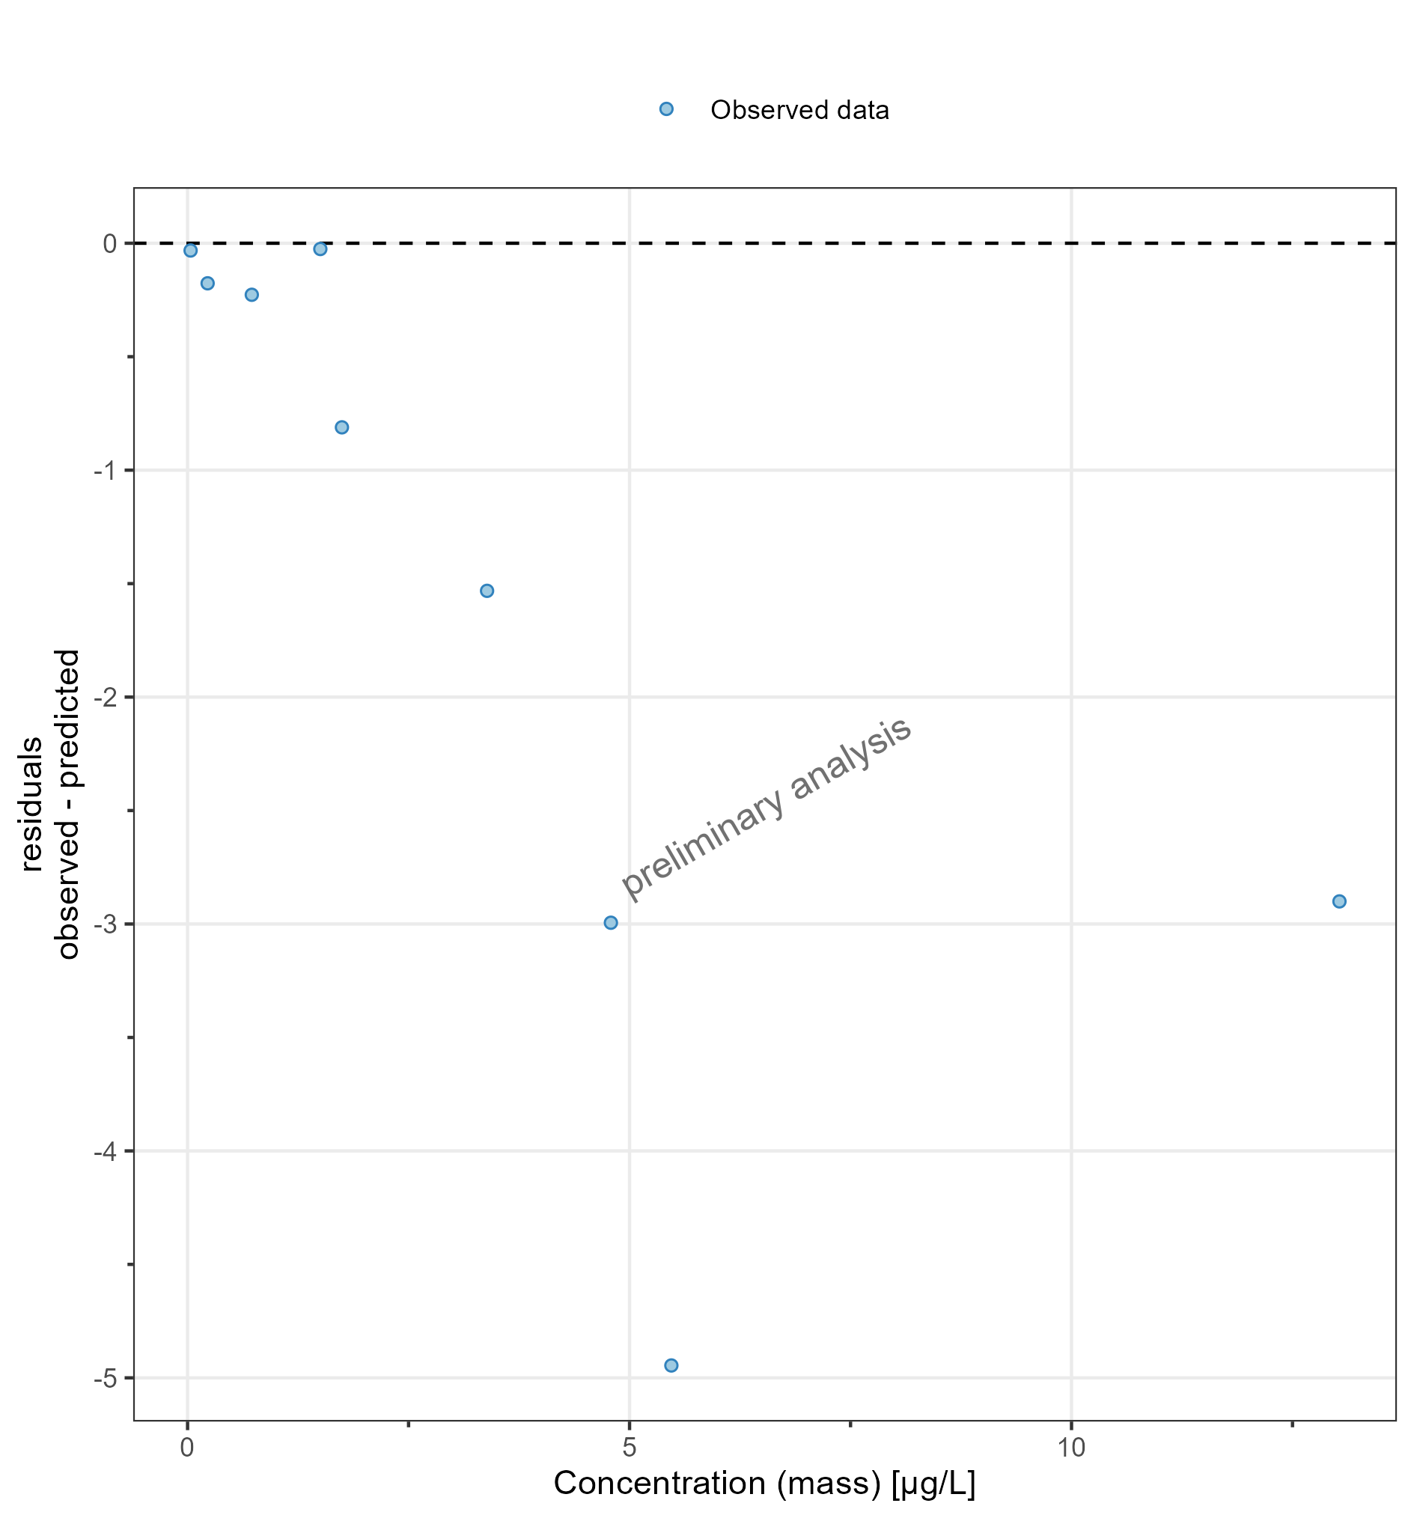

**Figure 9: Residuals vs observed values for DrugX Plasma for individual 1 of study 000 on a linear y-scale. DrugX was admistered as a 1mg Iv application with an infusion time of 5 minutes.**

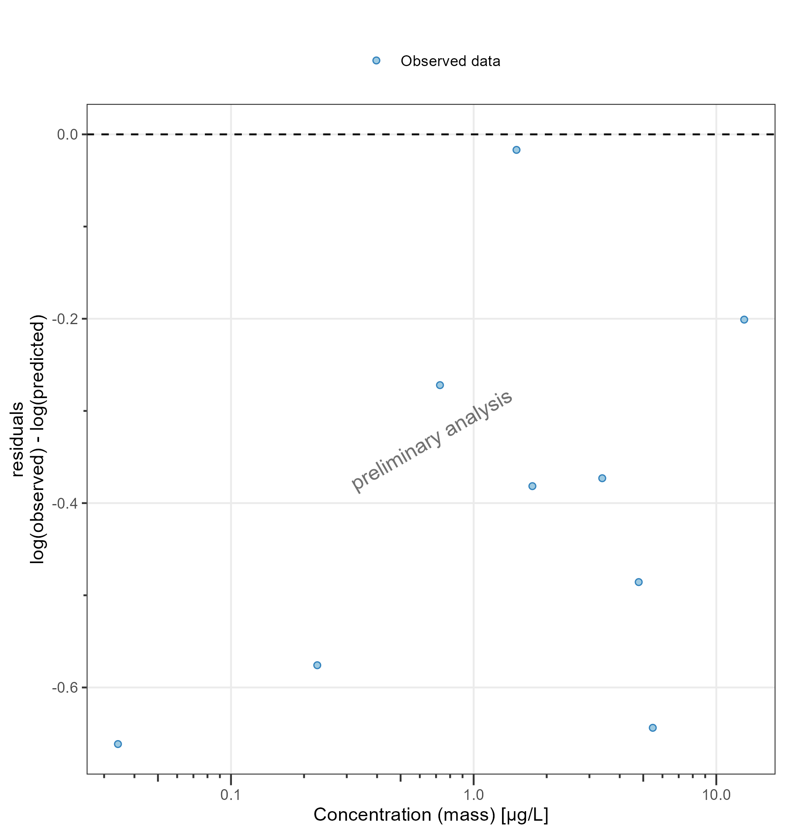

**Figure 10: Residuals vs observed values for DrugX Plasma for individual 1 of study 000 on a logarithmic y-scale. DrugX was admistered as a 1mg Iv application with an infusion time of 5 minutes.**

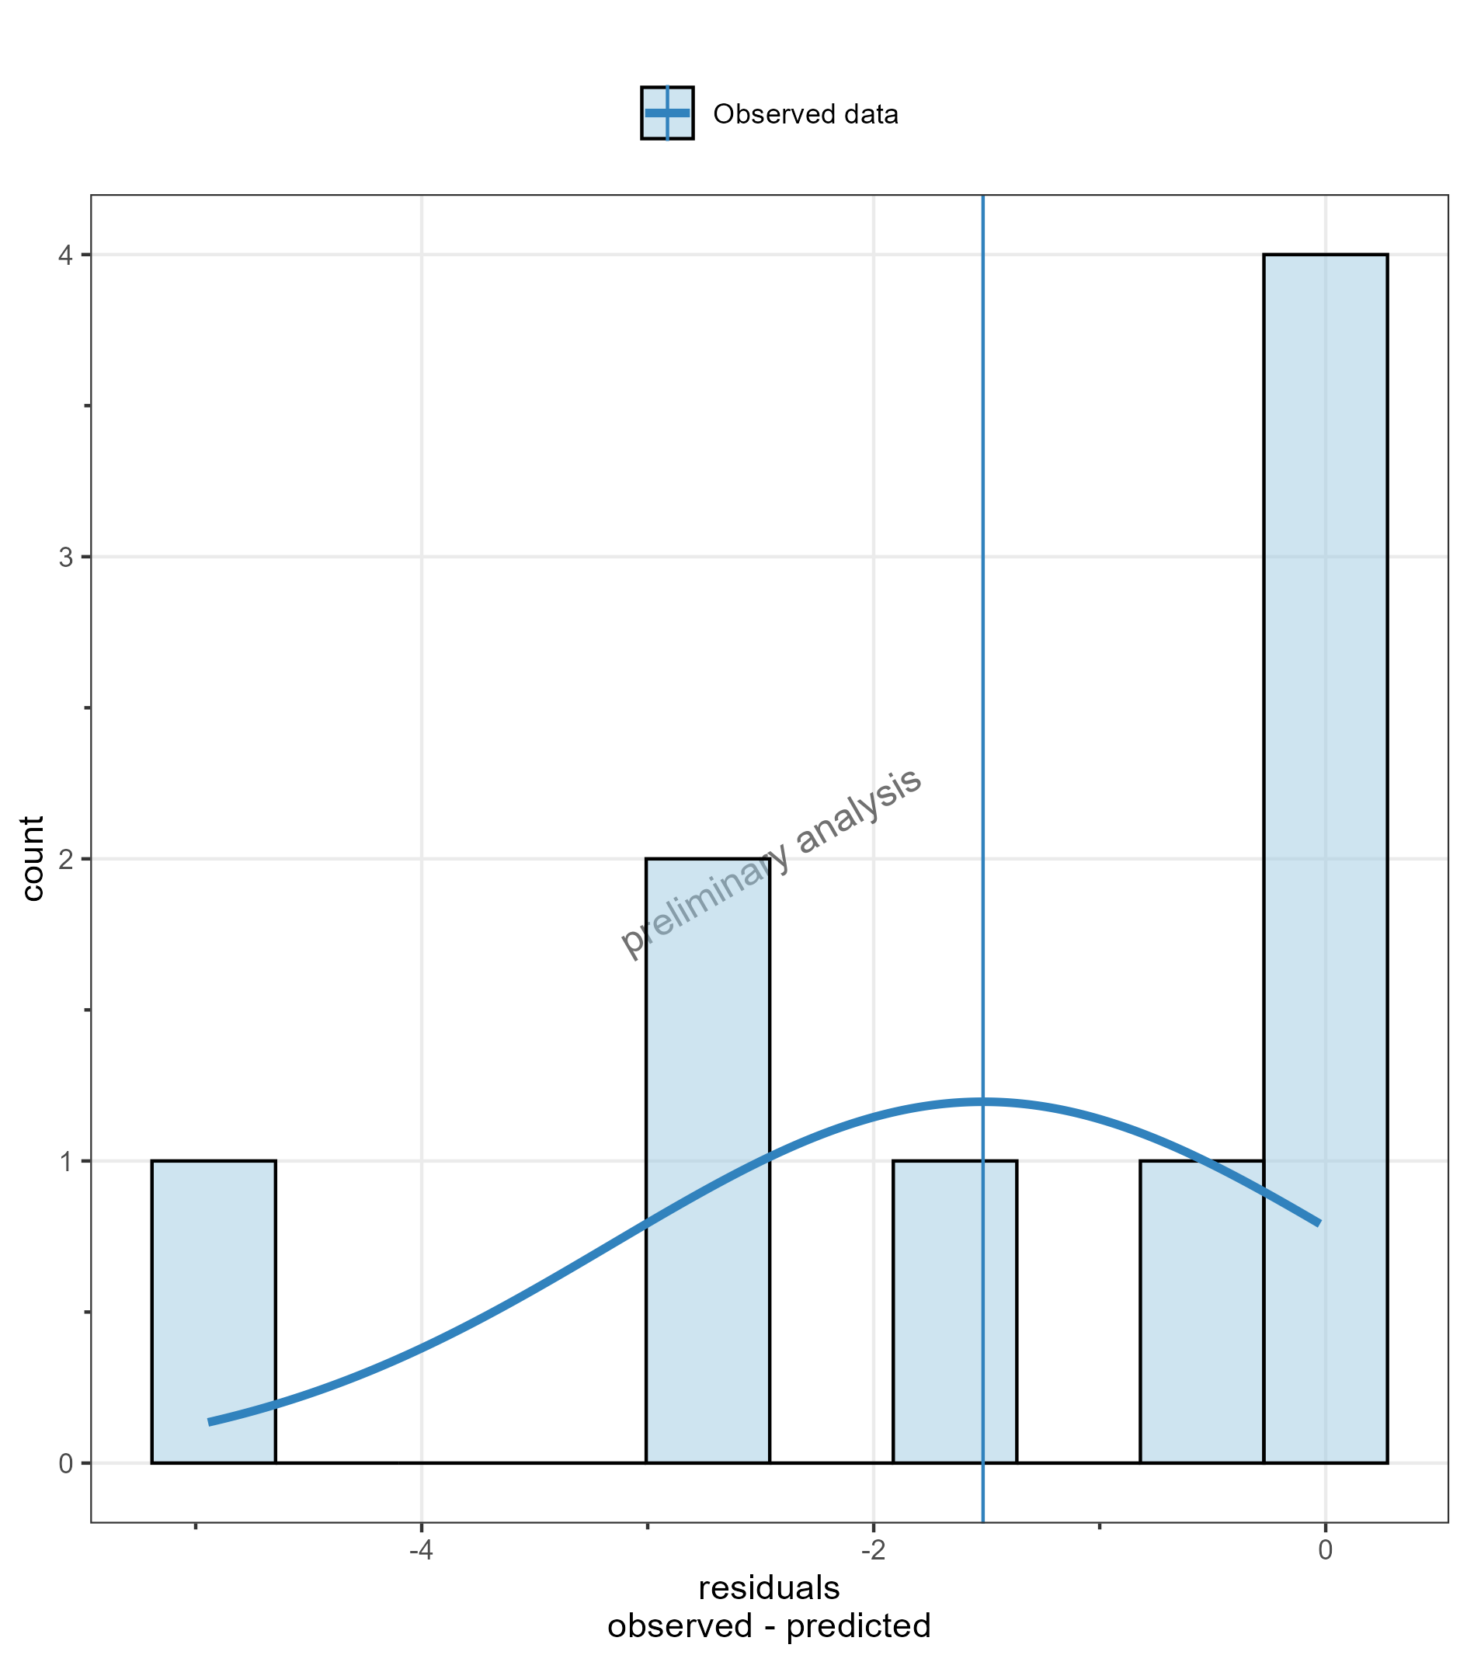

**Figure 11: Residuals distribution for DrugX Plasma for individual 1 of study 000 on a linear y-scale. DrugX was admistered as a 1mg Iv application with an infusion time of 5 minutes.**

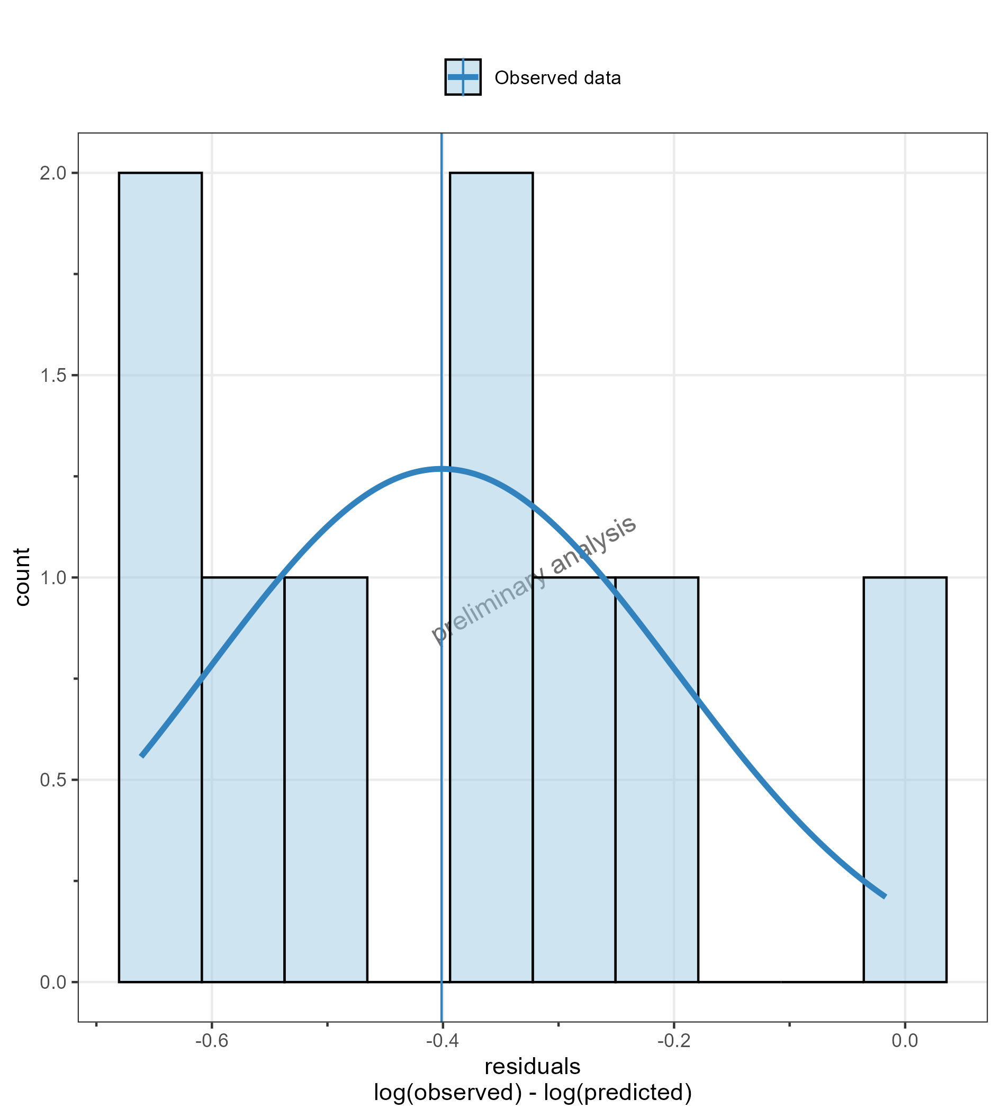

**Figure 12: Residuals distribution for DrugX Plasma for individual 1 of study 000 on a logarithmic y-scale. DrugX was admistered as a 1mg Iv application with an infusion time of 5 minutes.**

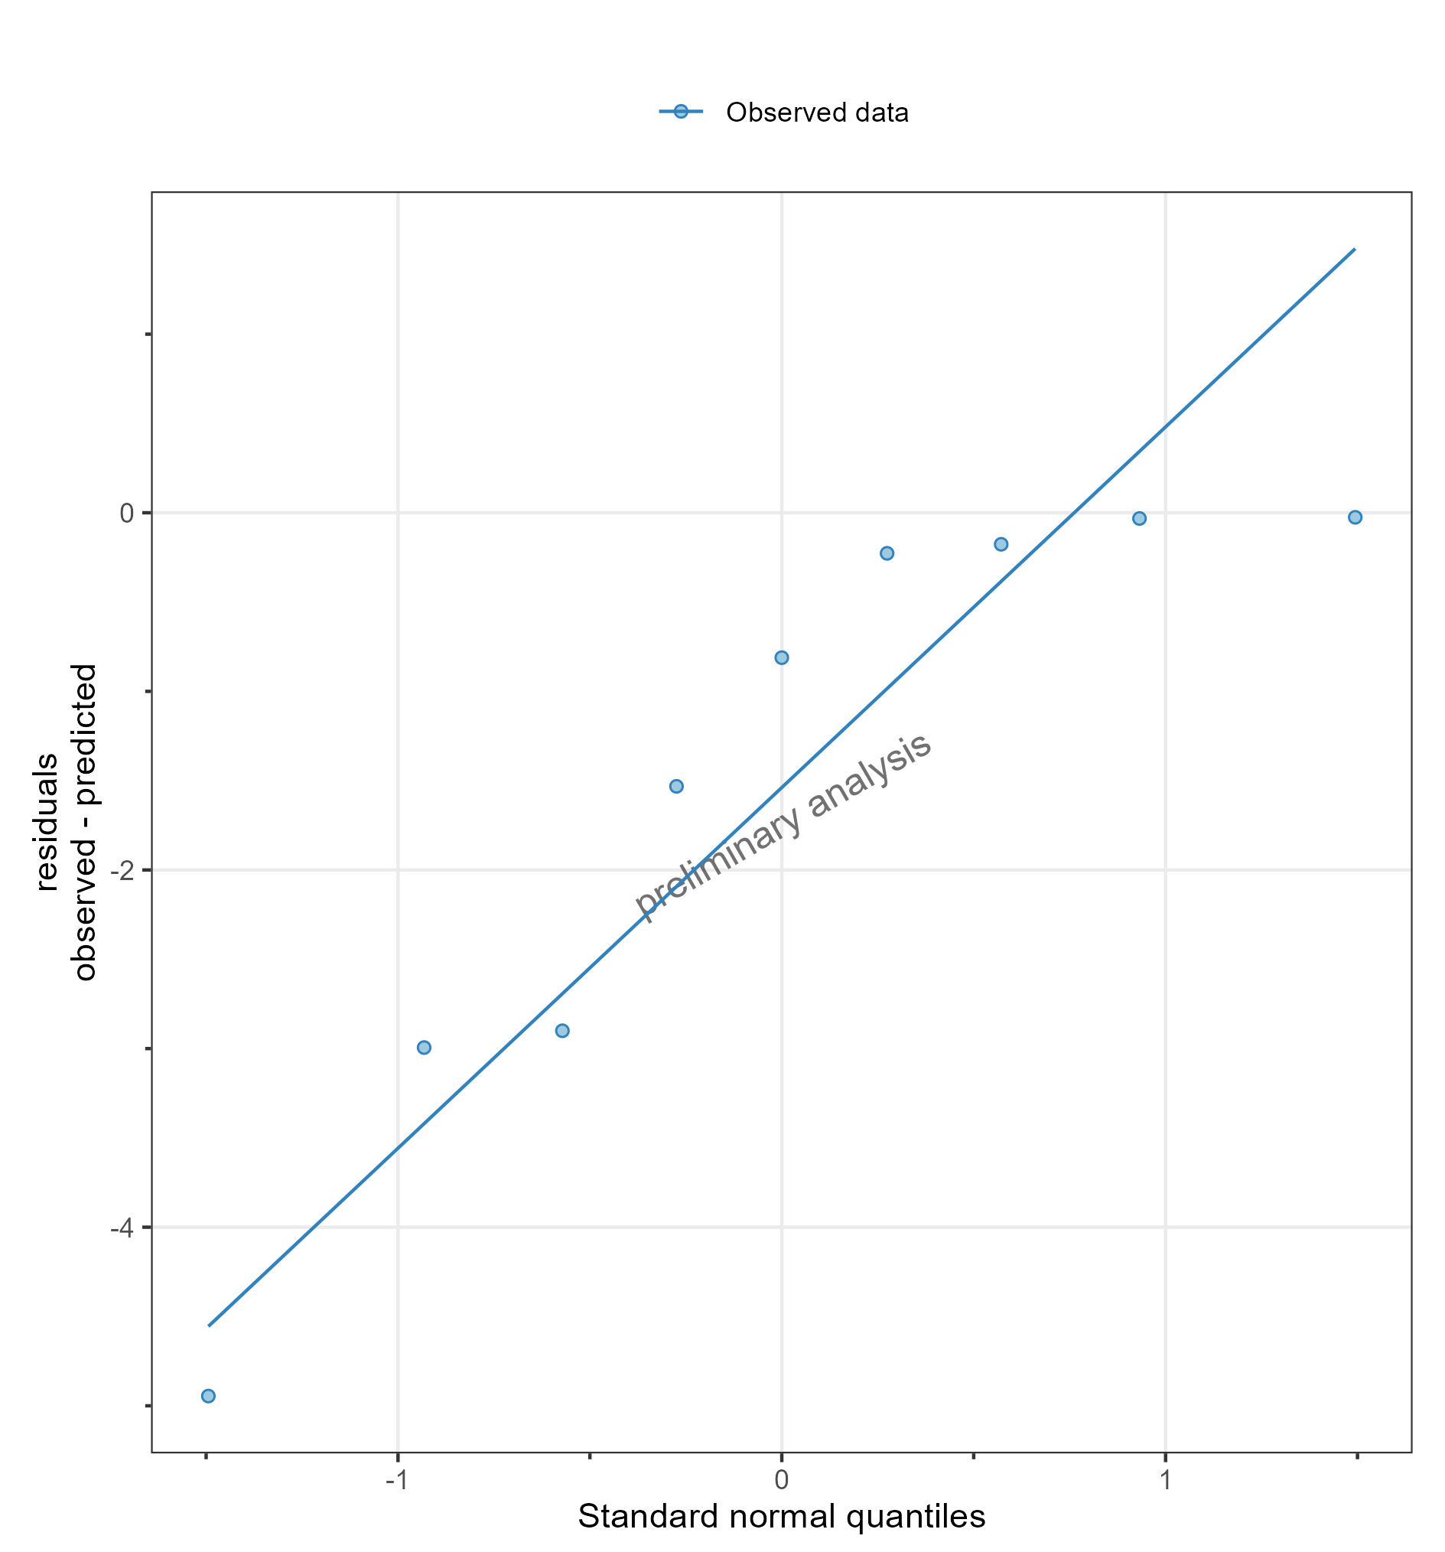

**Figure 13: Residuals as quantile-quantile plot for DrugX Plasma for individual 1 of study 000 on a linear y-scale. DrugX was admistered as a 1mg Iv application with an infusion time of 5 minutes.**

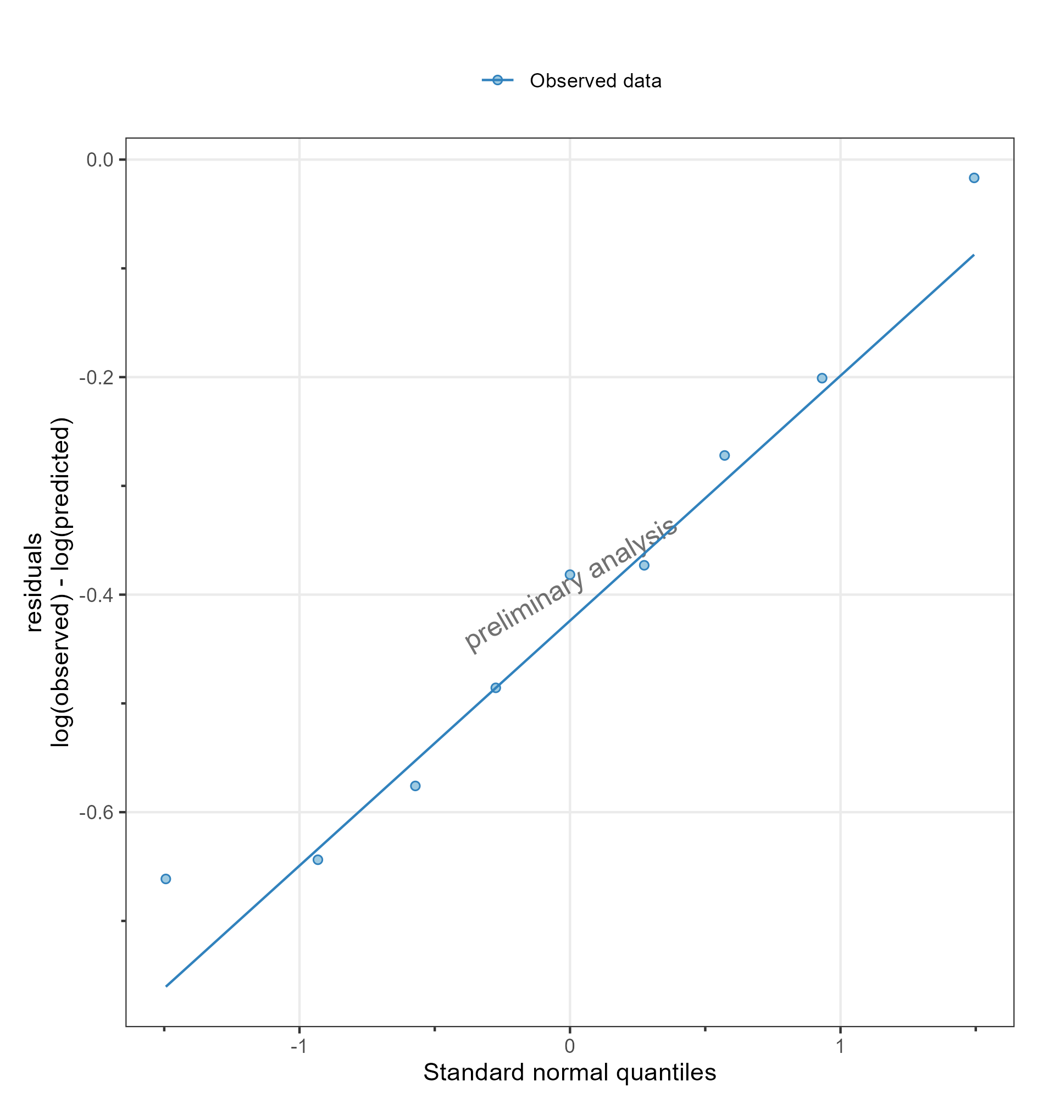

**Figure 14: Residuals as quantile-quantile plot for DrugX Plasma for individual 1 of study 000 on a logarithmic y-scale. DrugX was admistered as a 1mg Iv application with an infusion time of 5 minutes.**

## 2) Adding Virtual Twin Populations

### filtered individual

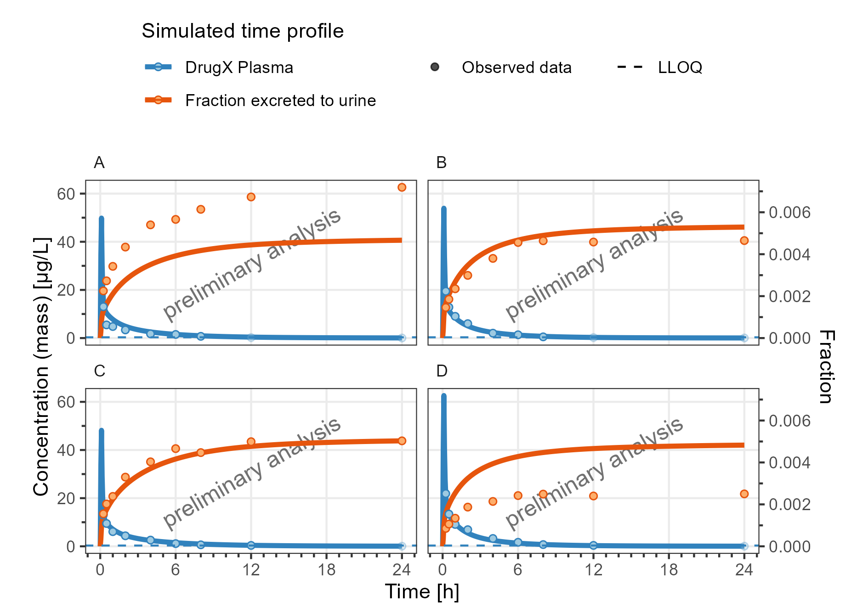

**Figure 15: Concentration-time profiles for DrugX Plasma and Fraction excreted to urine for individual simualtions of study 000 for subject 1 (A), 2 (B), 3 (C) and 4 (D) on a linear y-scale. DrugX was admistered as a 1mg Iv application with an infusion time of 5 minutes.**

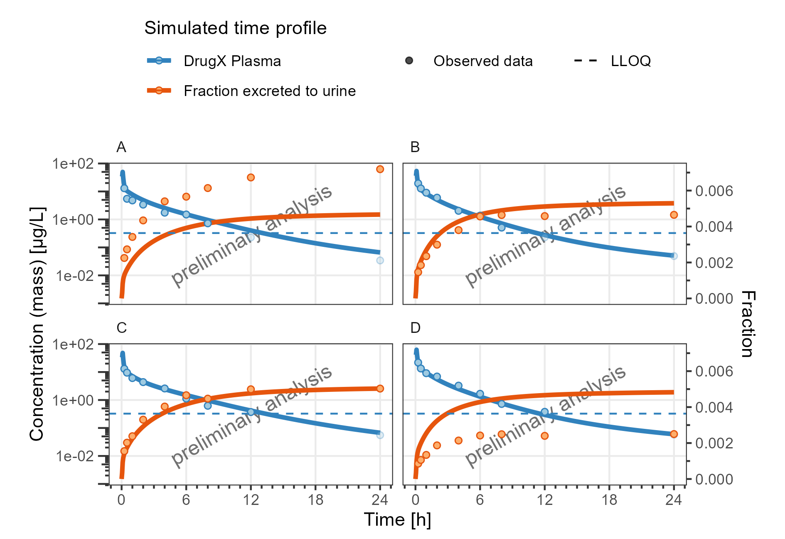

**Figure 16: Concentration-time profiles for DrugX Plasma and Fraction excreted to urine for individual simualtions of study 000 for subject 1 (A), 2 (B), 3 (C) and 4 (D) on a logarithmic y-scale. DrugX was admistered as a 1mg Iv application with an infusion time of 5 minutes.**

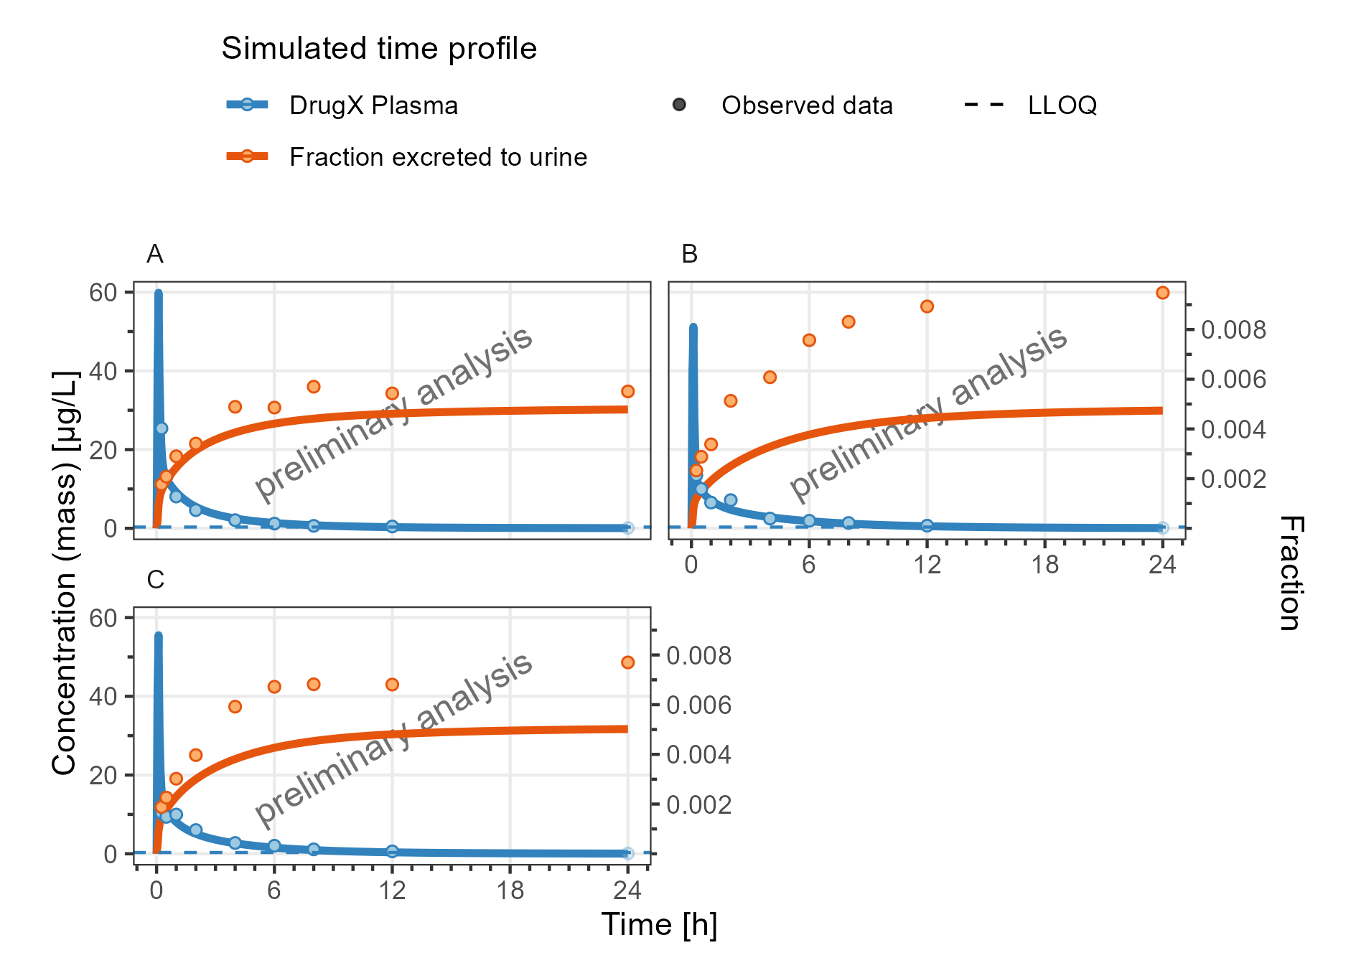

**Figure 17: Concentration-time profiles for DrugX Plasma and Fraction excreted to urine for individual simualtions of study 000 for subject 5 (A), 6 (B) and 7 (C) on a linear y-scale. DrugX was admistered as a 1mg Iv application with an infusion time of 5 minutes.**

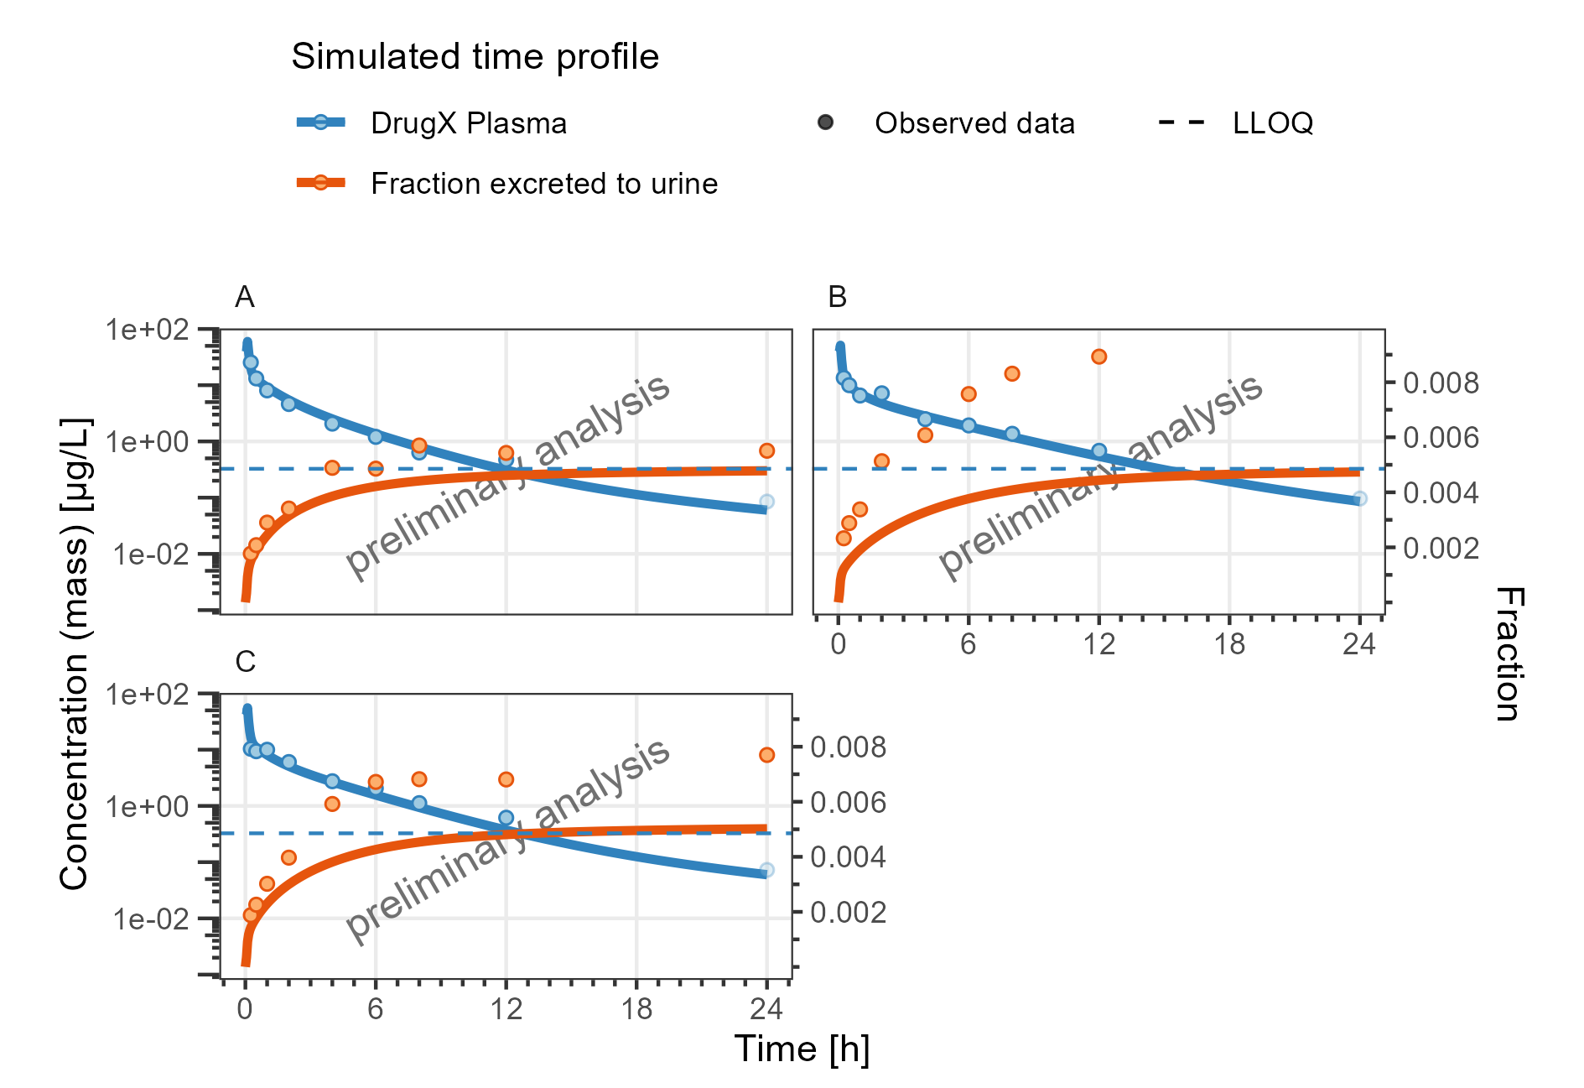

**Figure 18: Concentration-time profiles for DrugX Plasma and Fraction excreted to urine for individual simualtions of study 000 for subject 5 (A), 6 (B) and 7 (C) on a logarithmic y-scale. DrugX was admistered as a 1mg Iv application with an infusion time of 5 minutes.**

### shortcut for individual filter

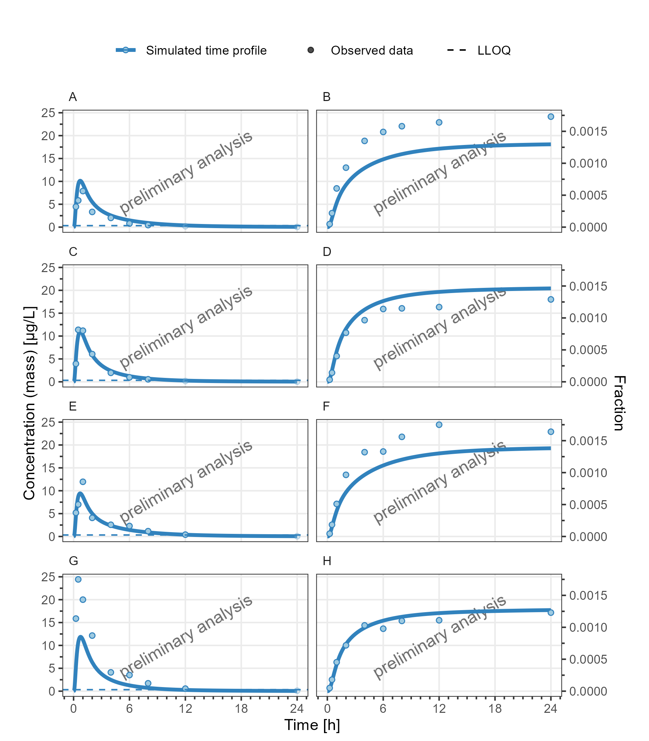

**Figure 19: Concentration-time profiles for DrugX Plasma (A, C, E, G) and Fraction excreted to urine (B, D, F, H) for individual simualtions of study 000 for subject 1 (A, B), 2 (C, D), 3 (E, F) and 4 (G, H) on a linear y-scale. DrugX was admistered as a 5mg oral application of a solution.**

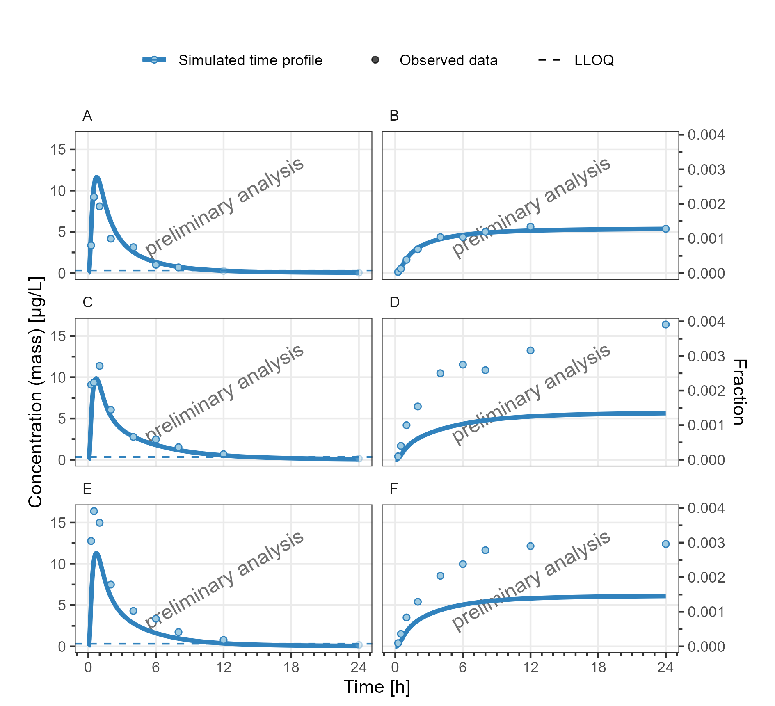

**Figure 20: Concentration-time profiles for DrugX Plasma (A, C, E) and Fraction excreted to urine (B, D, F) for individual simualtions of study 000 for subject 5 (A, B), 6 (C, D) and 7 (E, F) on a linear y-scale. DrugX was admistered as a 5mg oral application of a solution.**

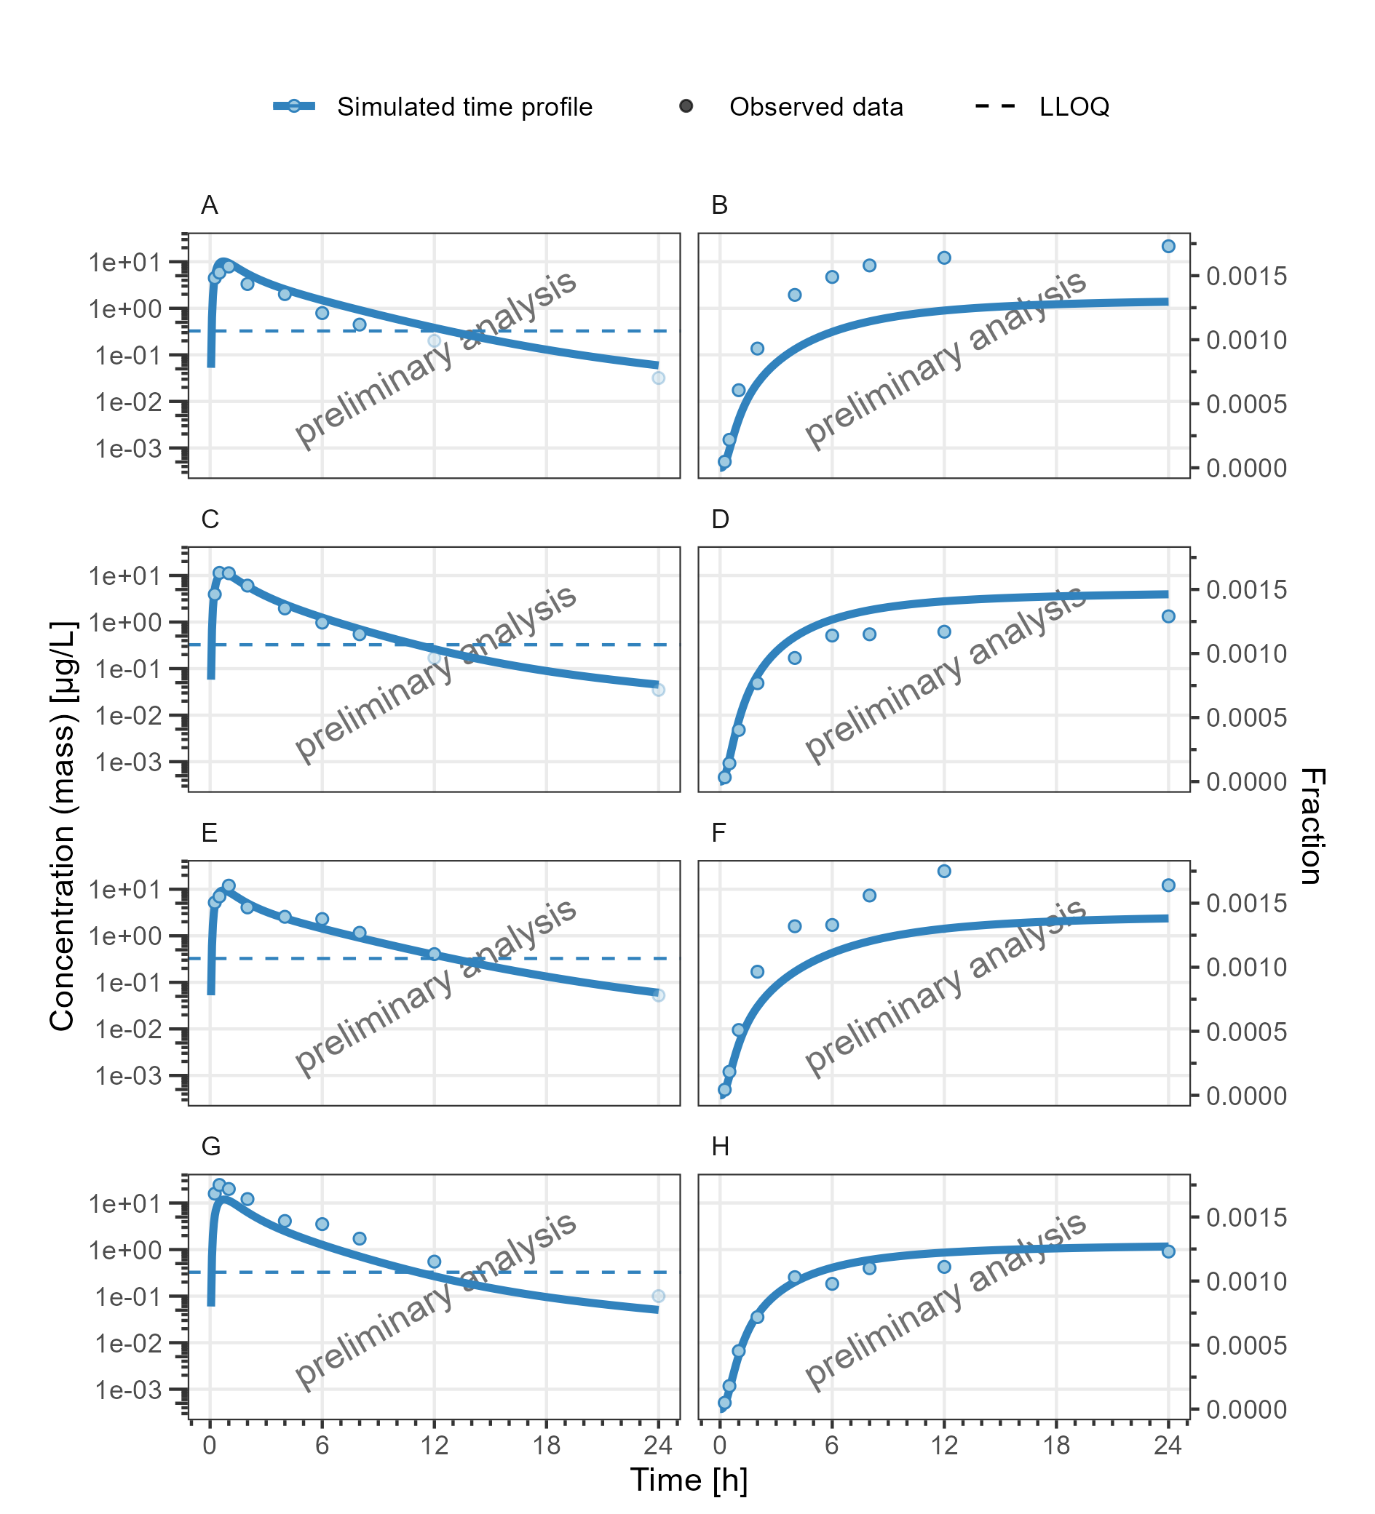

**Figure 21: Concentration-time profiles for DrugX Plasma (A, C, E, G) and Fraction excreted to urine (B, D, F, H) for individual simualtions of study 000 for subject 1 (A, B), 2 (C, D), 3 (E, F) and 4 (G, H) on a logarithmic y-scale. DrugX was admistered as a 5mg oral application of a solution.**

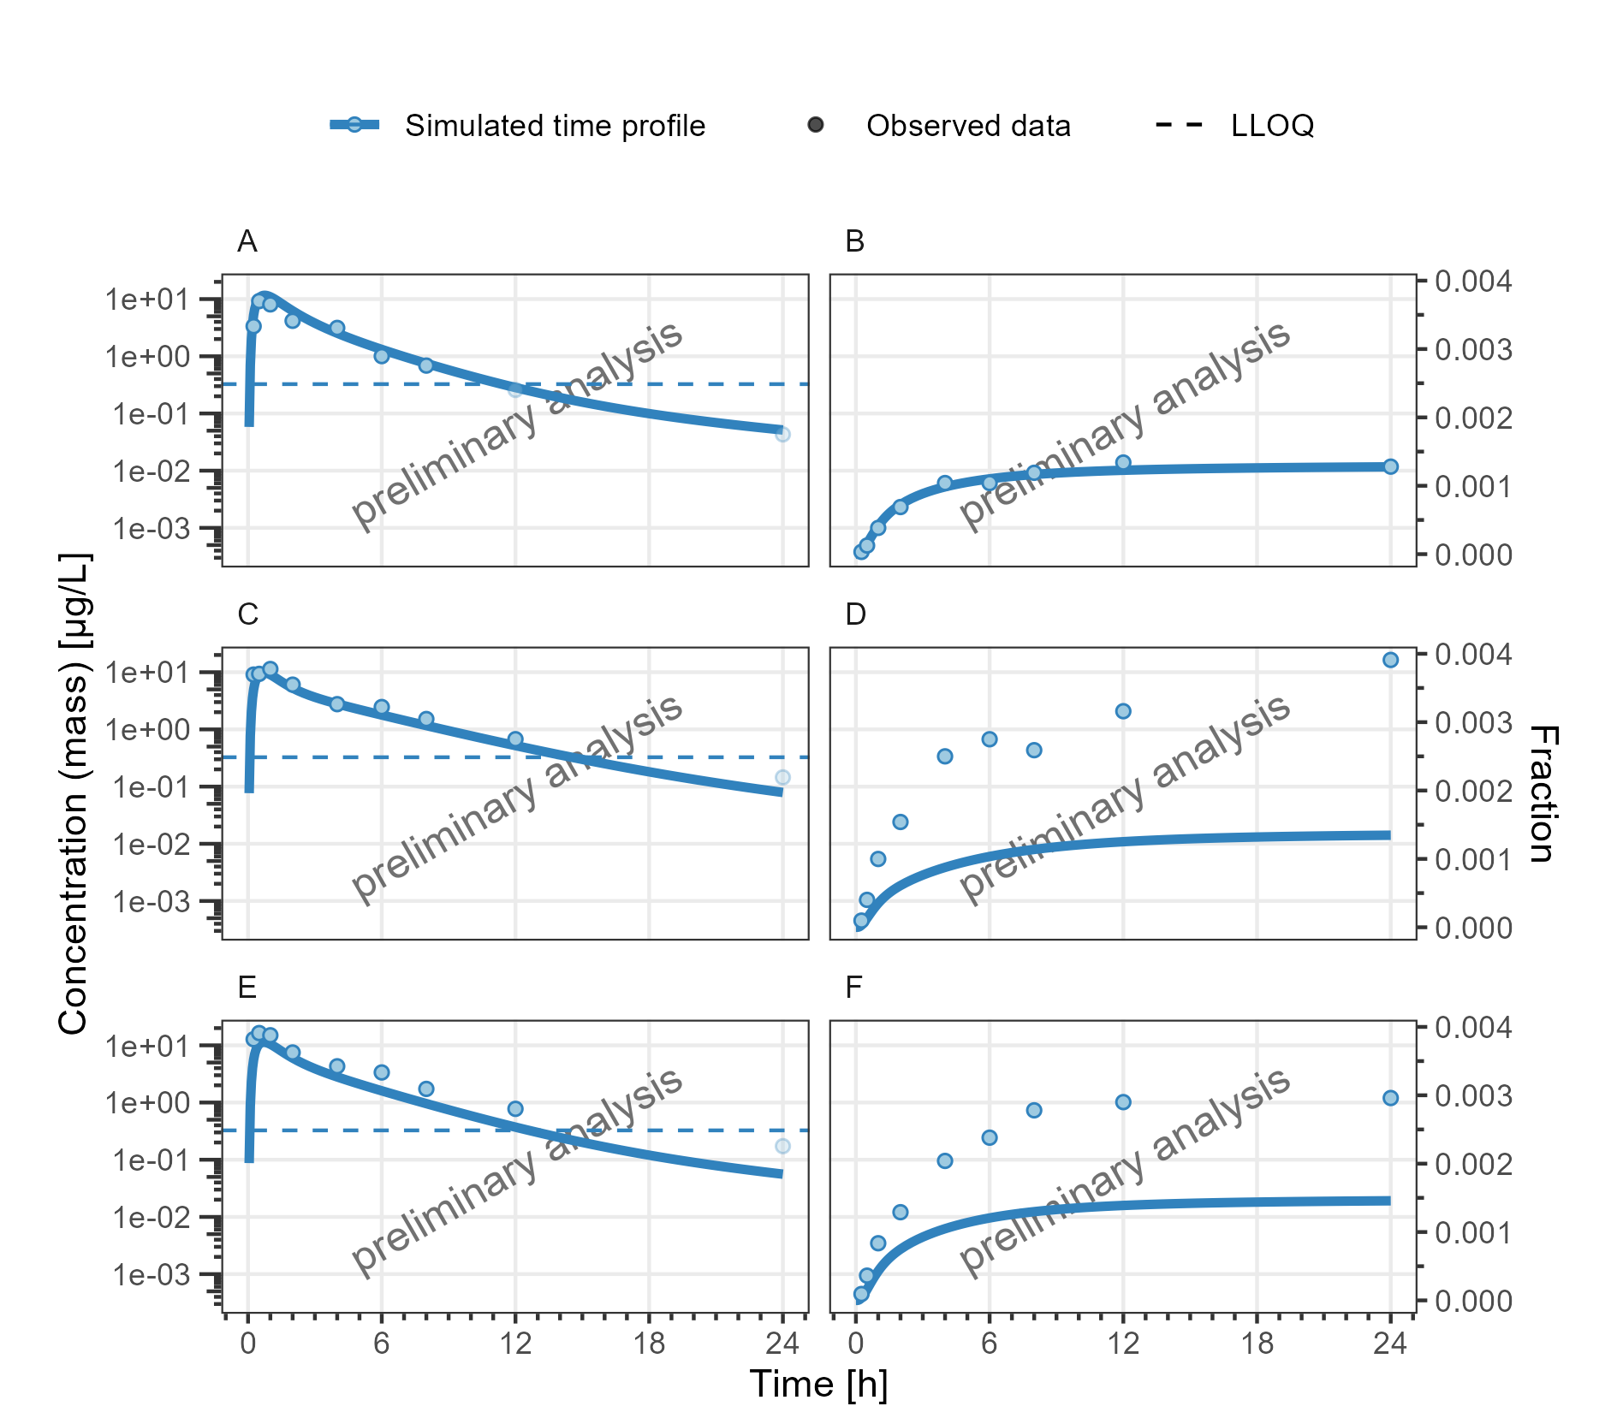

**Figure 22: Concentration-time profiles for DrugX Plasma (A, C, E) and Fraction excreted to urine (B, D, F) for individual simualtions of study 000 for subject 5 (A, B), 6 (C, D) and 7 (E, F) on a logarithmic y-scale. DrugX was admistered as a 5mg oral application of a solution.**

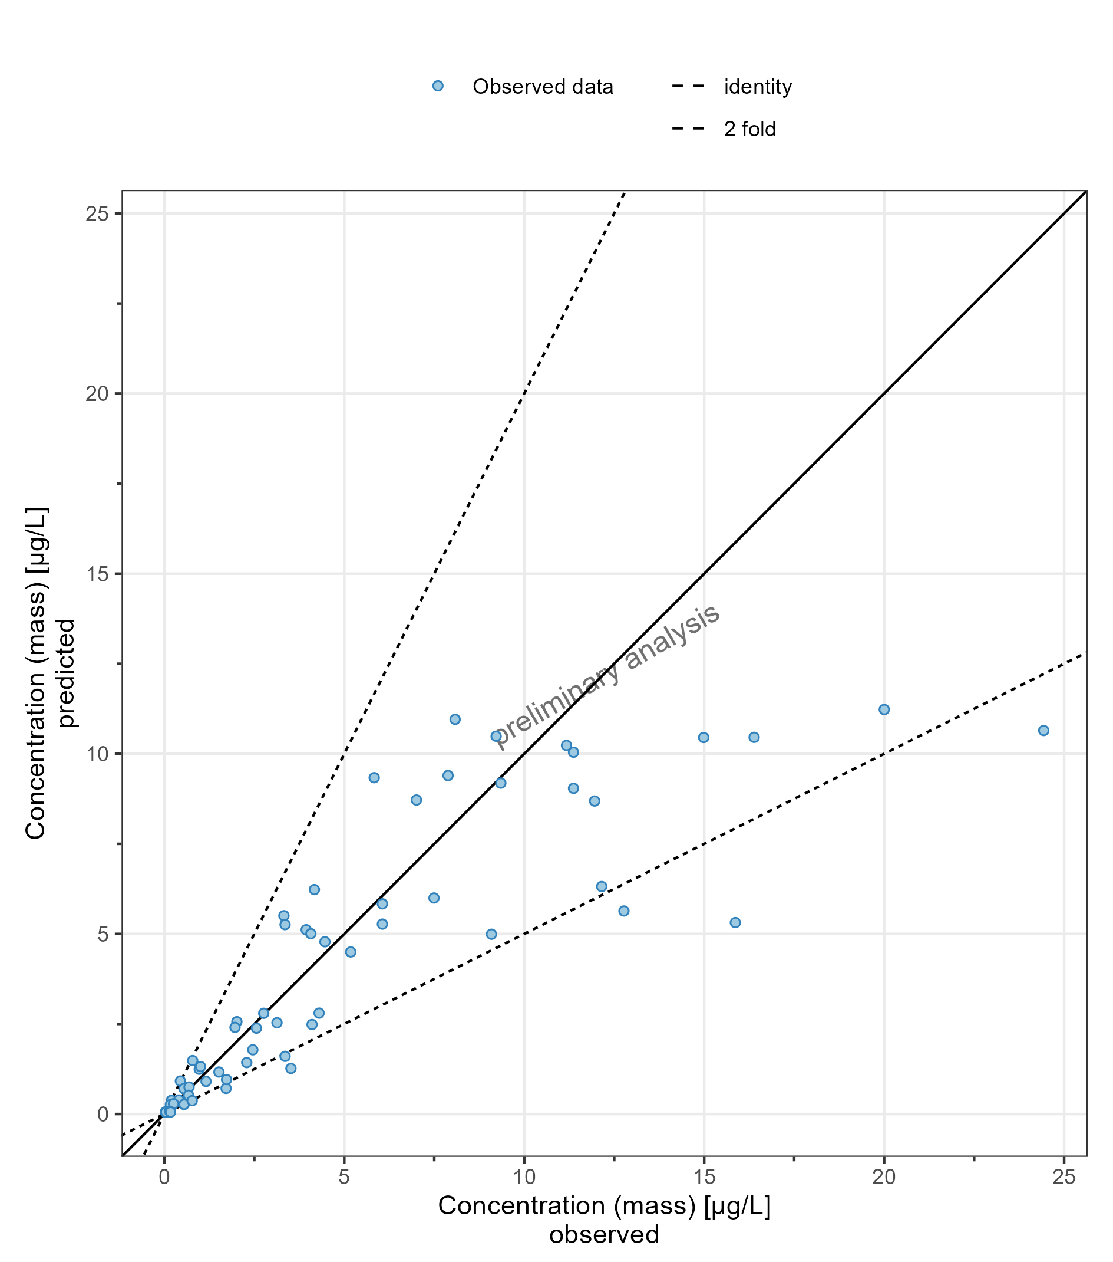

**Figure 23: Predicted vs Observed for DrugX Plasma for individual simualtions of study 000 for subject on a linear y-scale. DrugX was admistered as a 5mg oral application of a solution.**

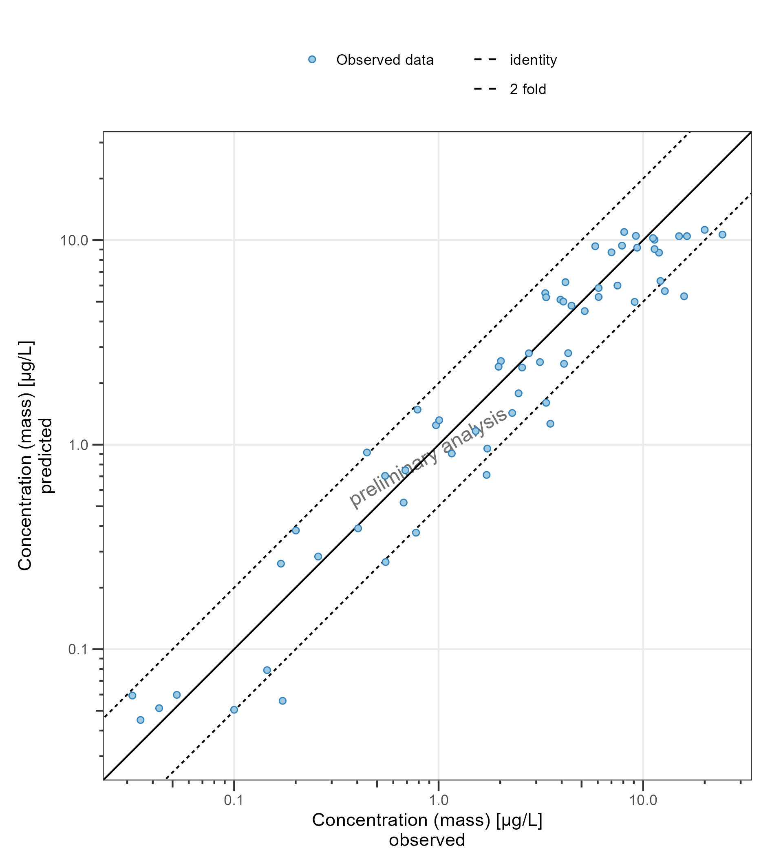

**Figure 24: Predicted vs Observed for DrugX Plasma for individual simualtions of study 000 for subject on a logarithmic y-scale. DrugX was admistered as a 5mg oral application of a solution.**

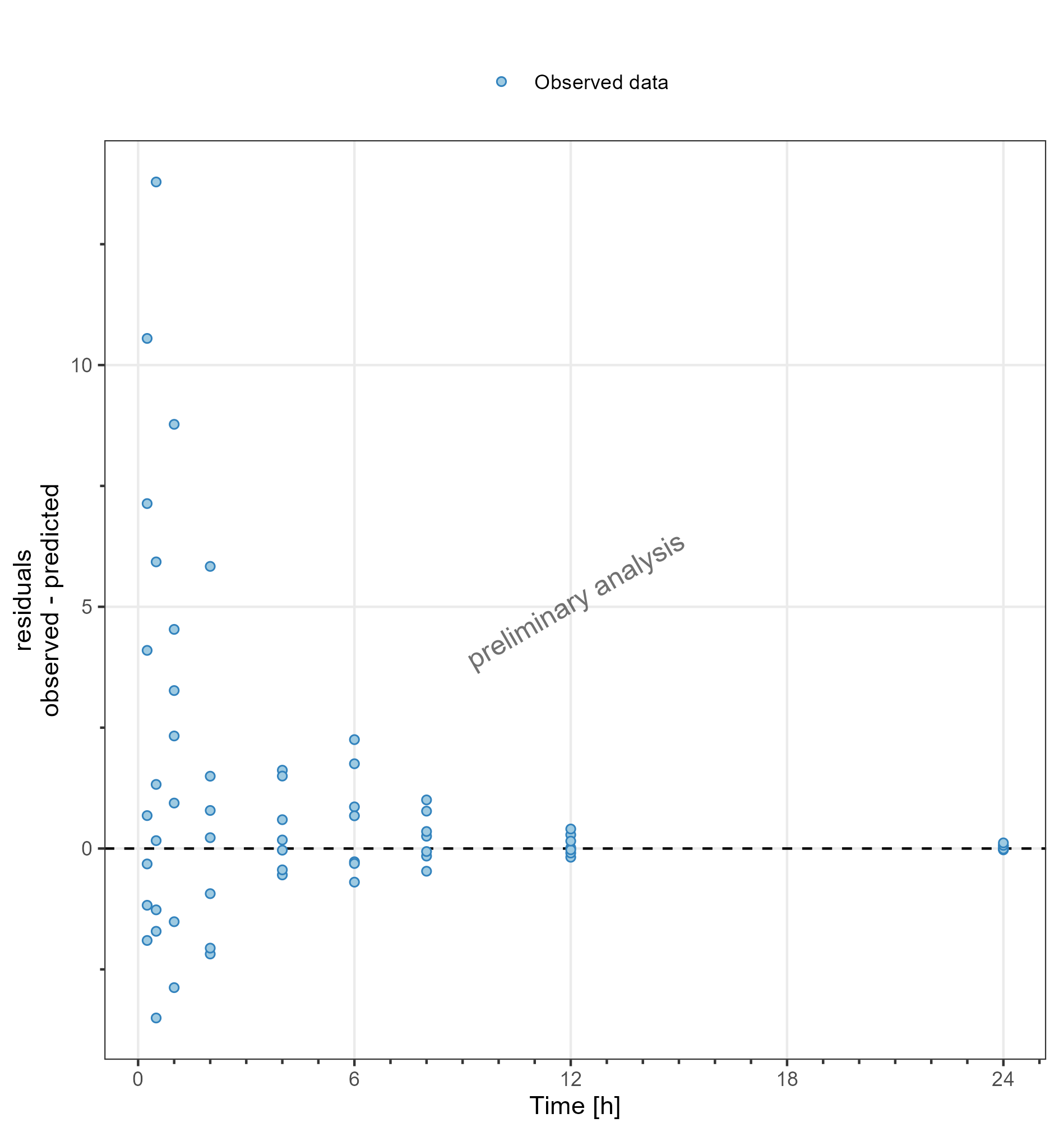

**Figure 25: Residuals vs time values for DrugX Plasma for individual simualtions of study 000 for subject on a linear y-scale. DrugX was admistered as a 5mg oral application of a solution.**

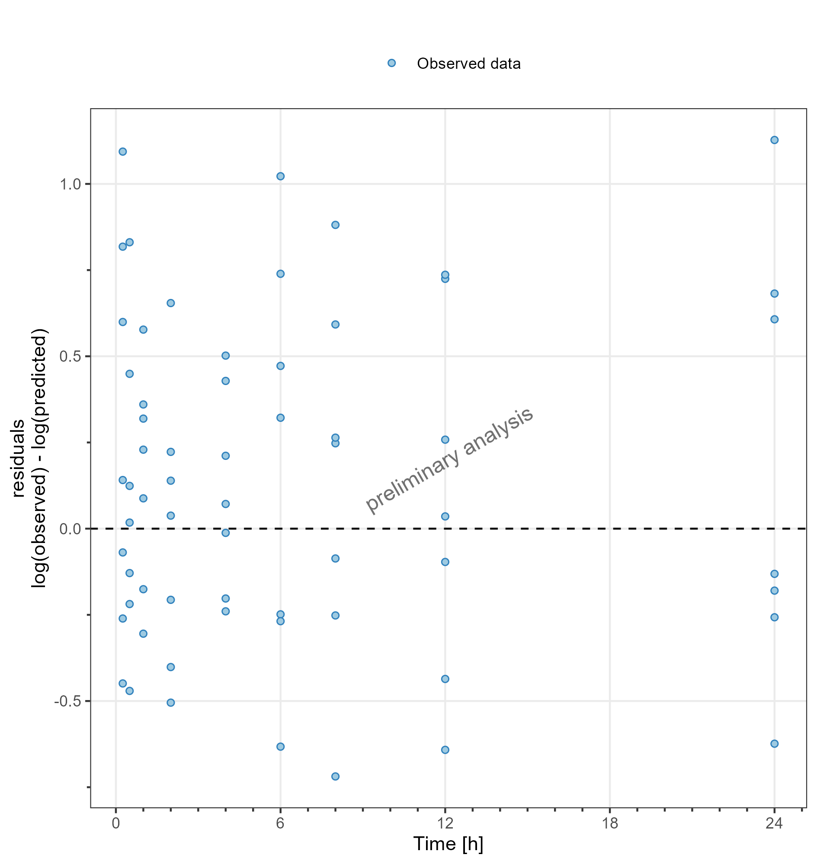

**Figure 26: Residuals vs time values for DrugX Plasma for individual simualtions of study 000 for subject on a logarithmic y-scale. DrugX was admistered as a 5mg oral application of a solution.**

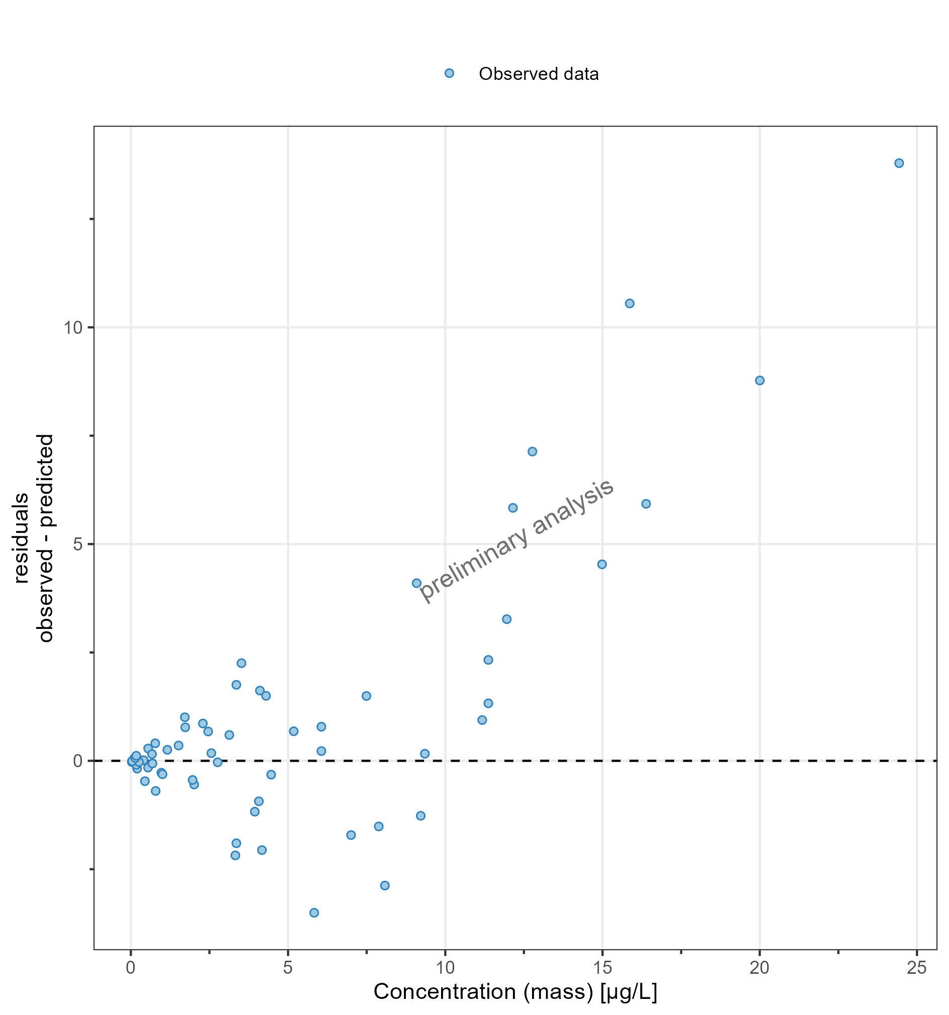

**Figure 27: Residuals vs observed values for DrugX Plasma for individual simualtions of study 000 for subject on a linear y-scale. DrugX was admistered as a 5mg oral application of a solution.**

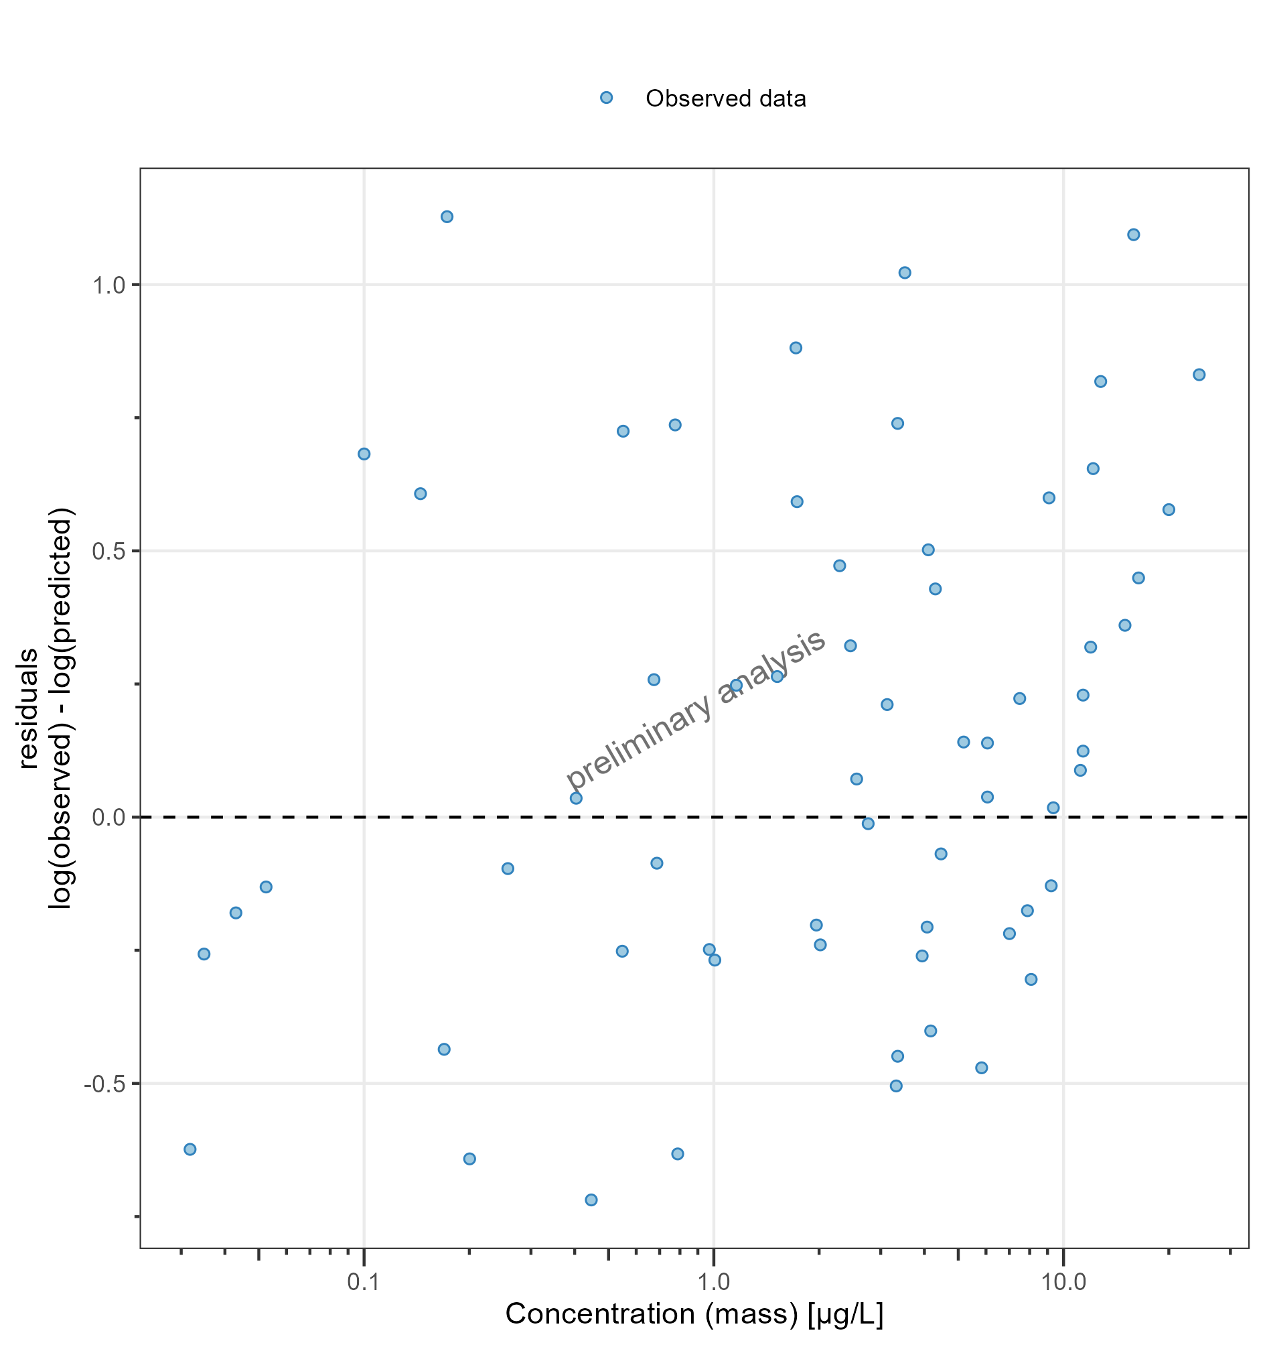

**Figure 28: Residuals vs observed values for DrugX Plasma for individual simualtions of study 000 for subject on a logarithmic y-scale. DrugX was admistered as a 5mg oral application of a solution.**

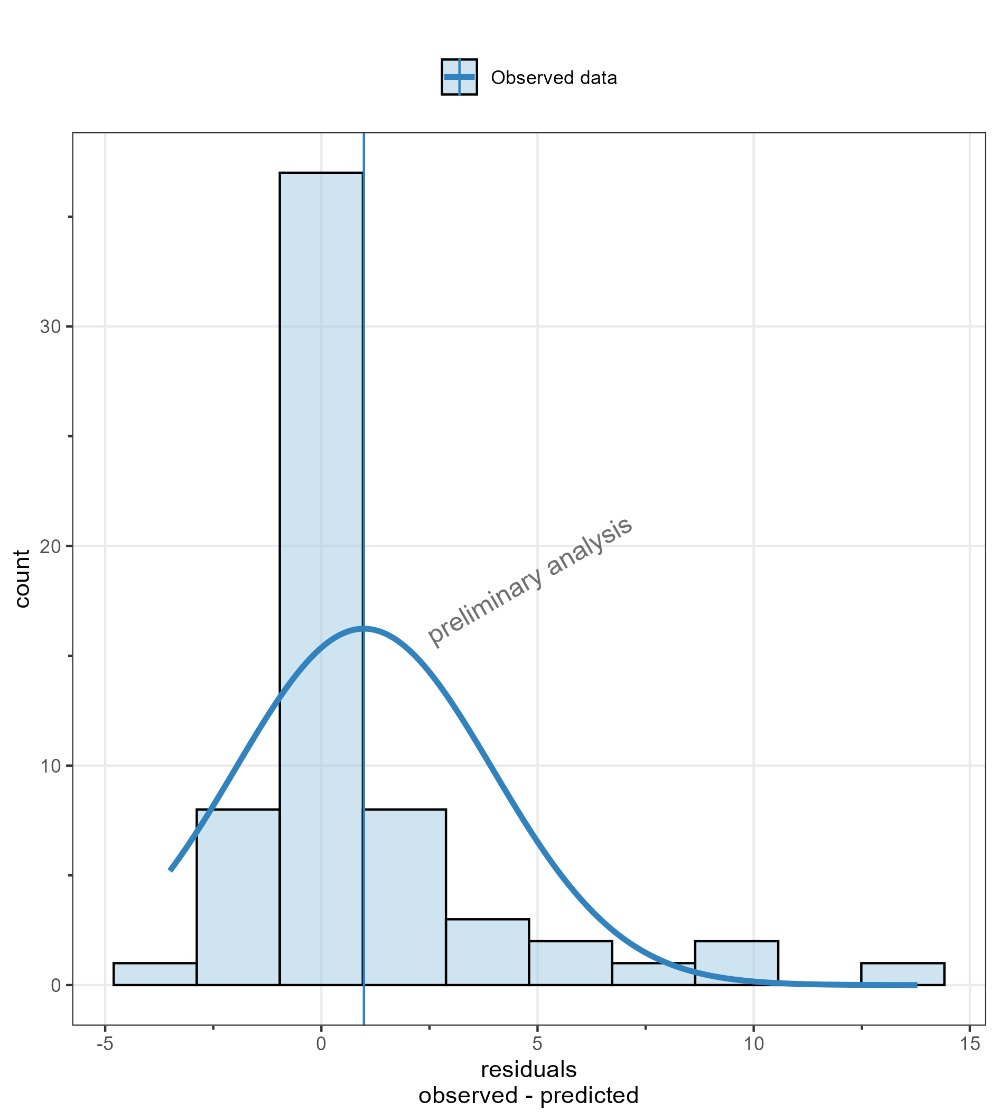

**Figure 29: Residuals distribution for DrugX Plasma for individual simualtions of study 000 for subject on a linear y-scale. DrugX was admistered as a 5mg oral application of a solution.**

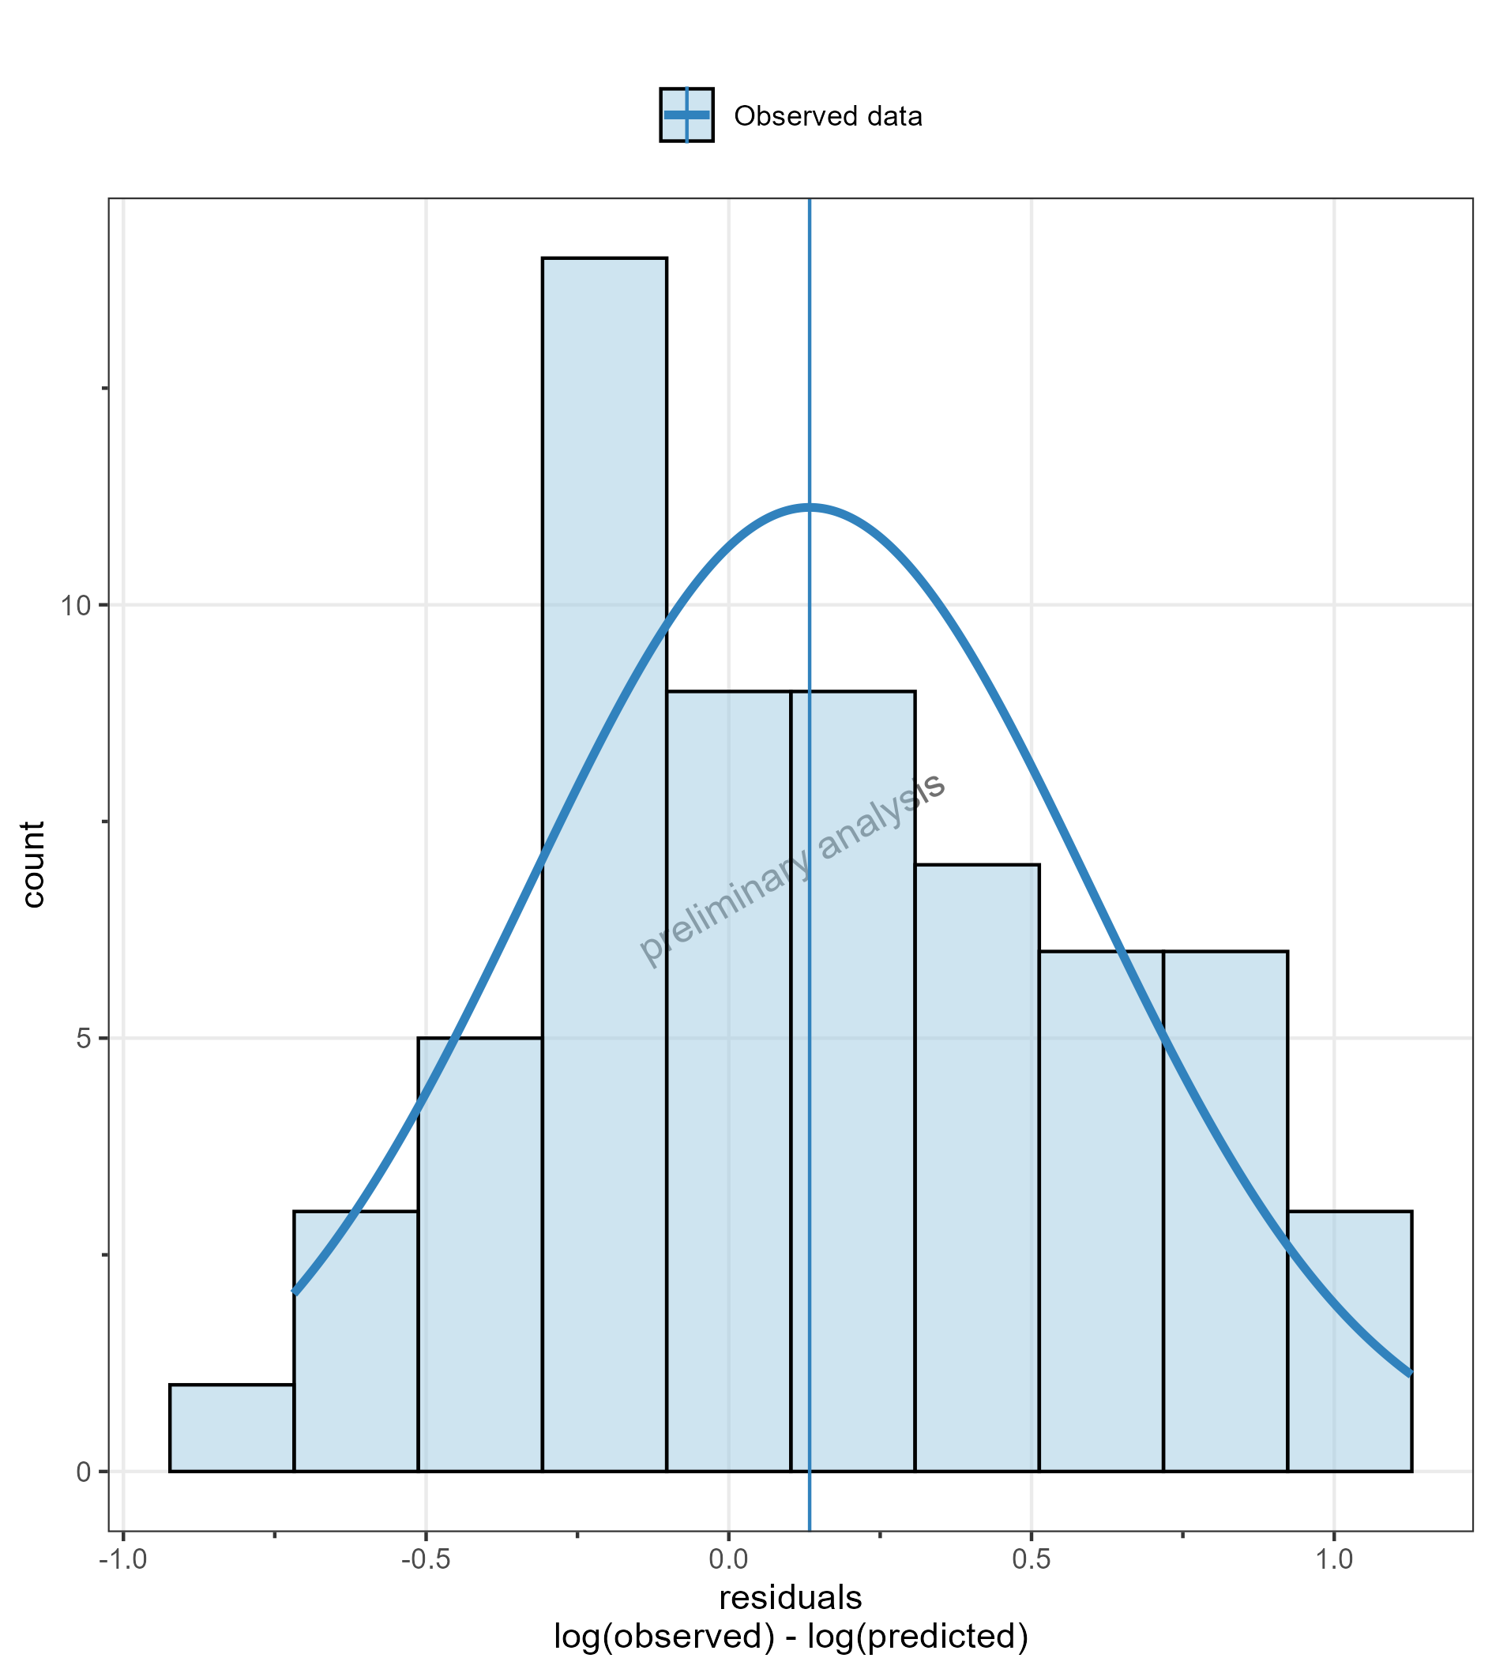

**Figure 30: Residuals distribution for DrugX Plasma for individual simualtions of study 000 for subject on a logarithmic y-scale. DrugX was admistered as a 5mg oral application of a solution.**

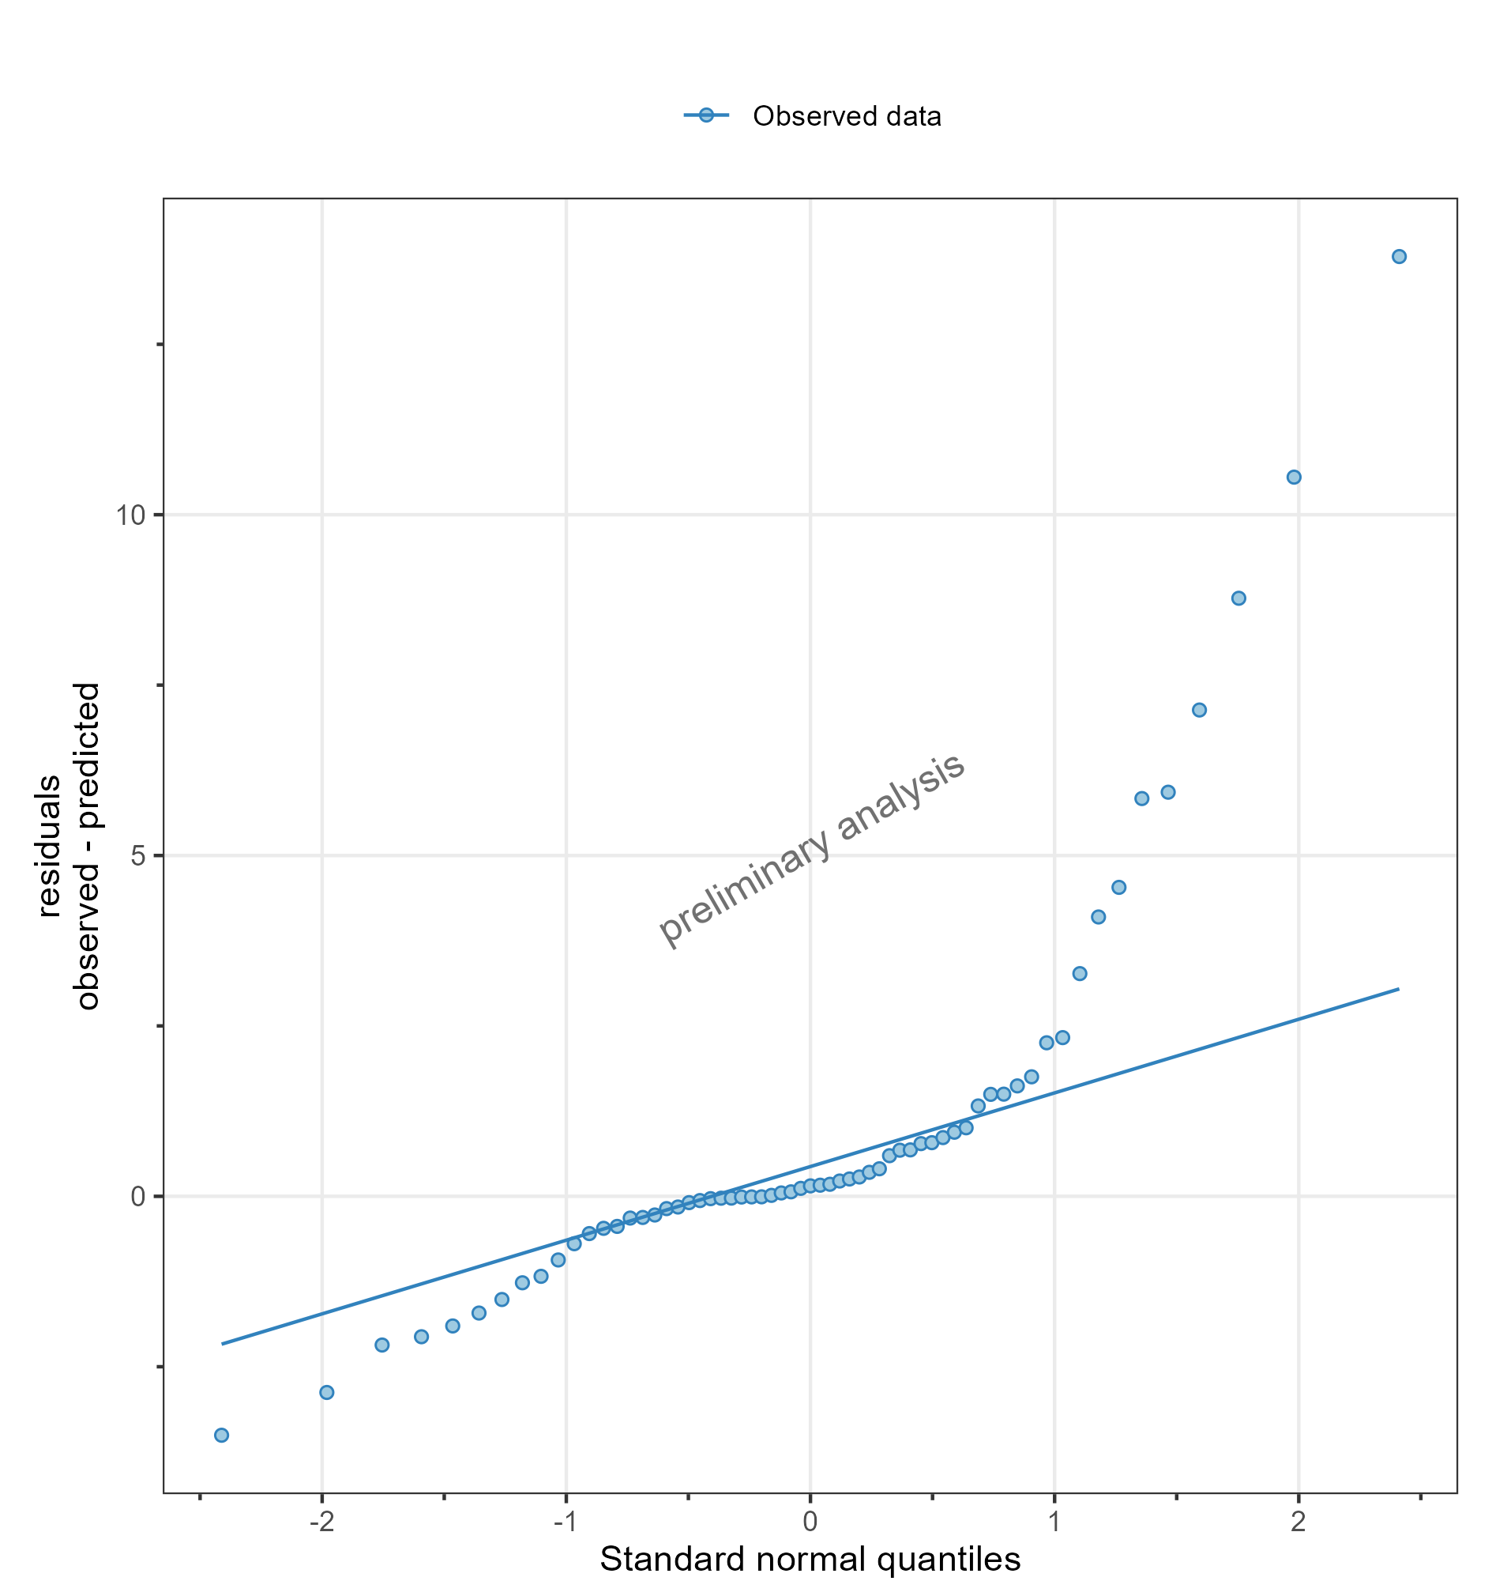

**Figure 31: Residuals as quantile-quantile plot for DrugX Plasma for individual simualtions of study 000 for subject on a linear y-scale. DrugX was admistered as a 5mg oral application of a solution.**

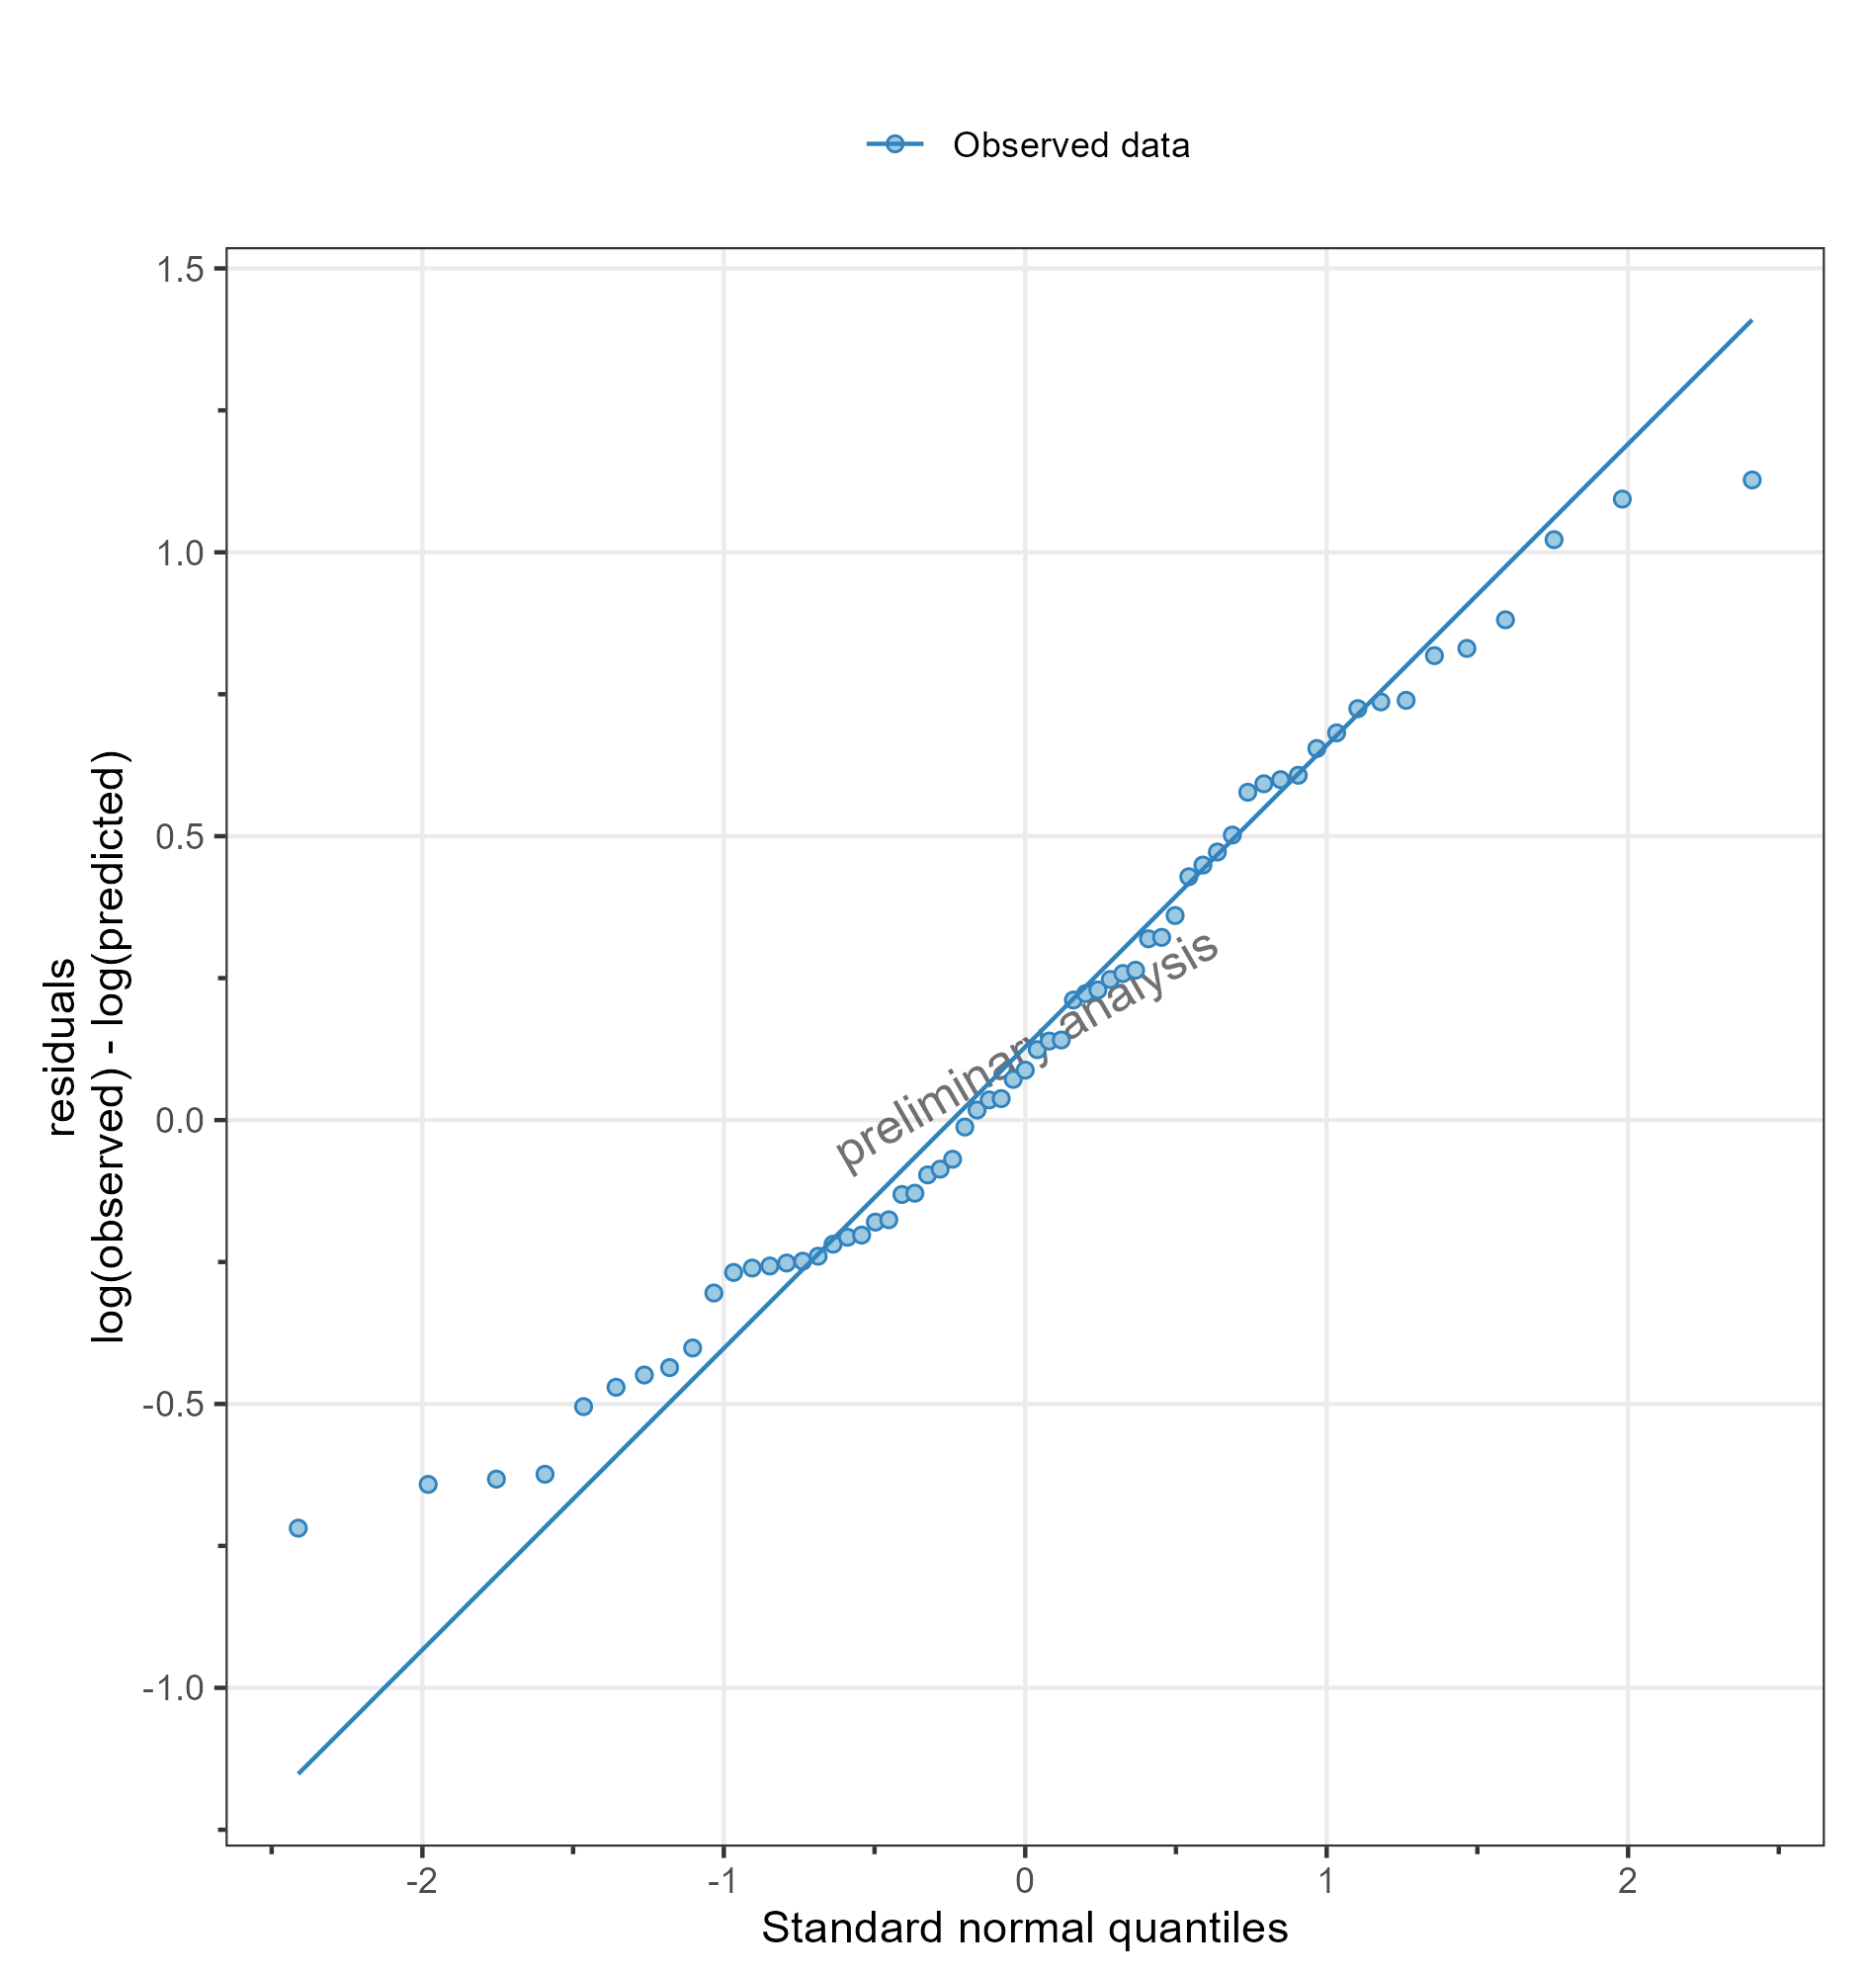

**Figure 32: Residuals as quantile-quantile plot for DrugX Plasma for individual simualtions of study 000 for subject on a logarithmic y-scale. DrugX was admistered as a 5mg oral application of a solution.**

## 3) Adding Random Populations and use of aggregated data

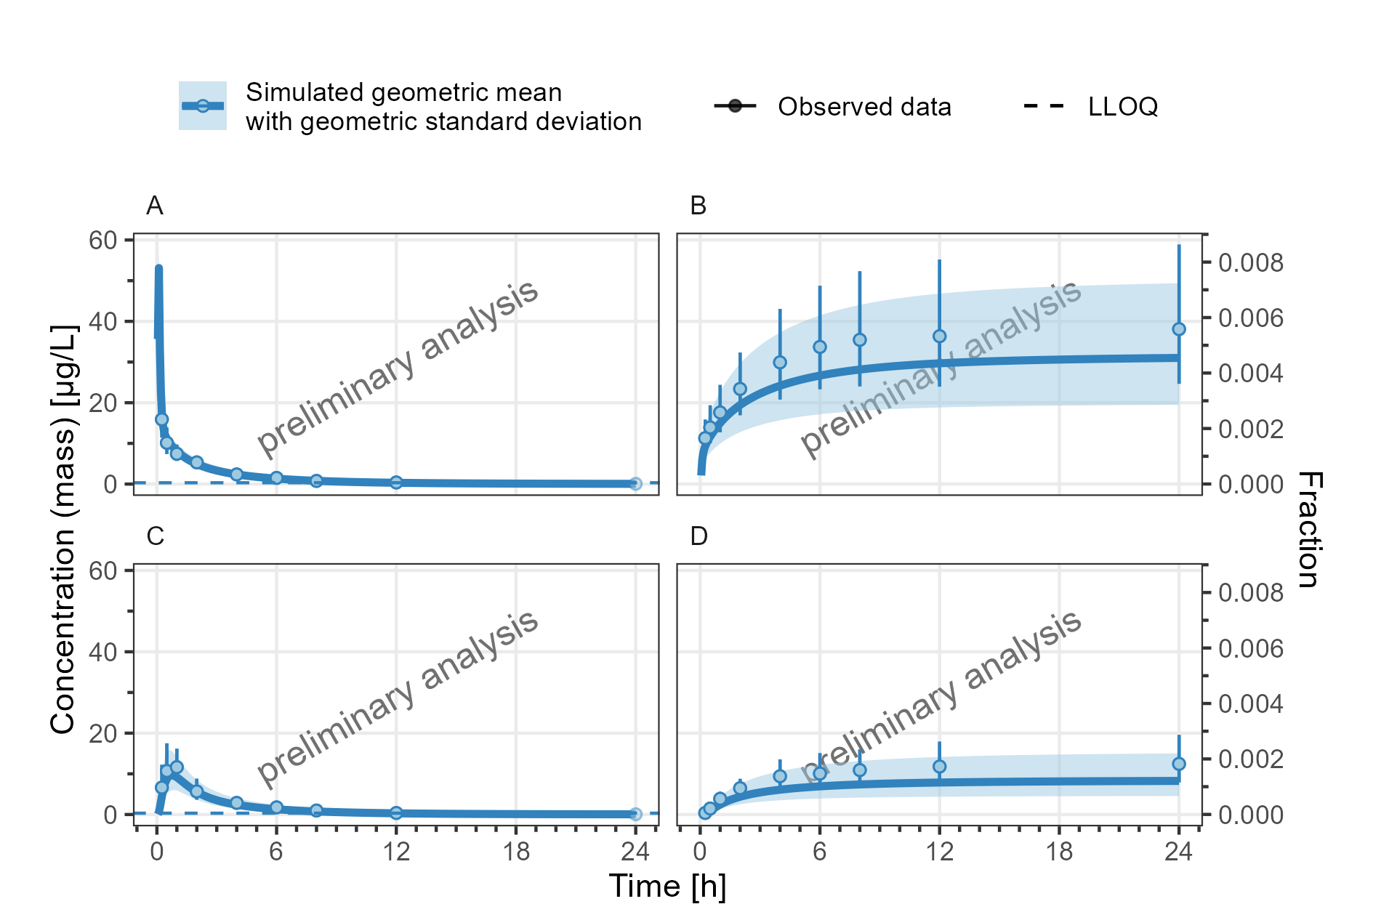

Observed data is displayed as geometric mean and geometric standard deviation  
**Figure 33: Concentration-time profiles for DrugX Plasma (A, C) and Fraction excreted to urine (B, D) for random population simulation of a 1mg 5min iv administration (A, B) and random population simulation of a 5mg oral administration (C, D) on a linear y-scale. NA**

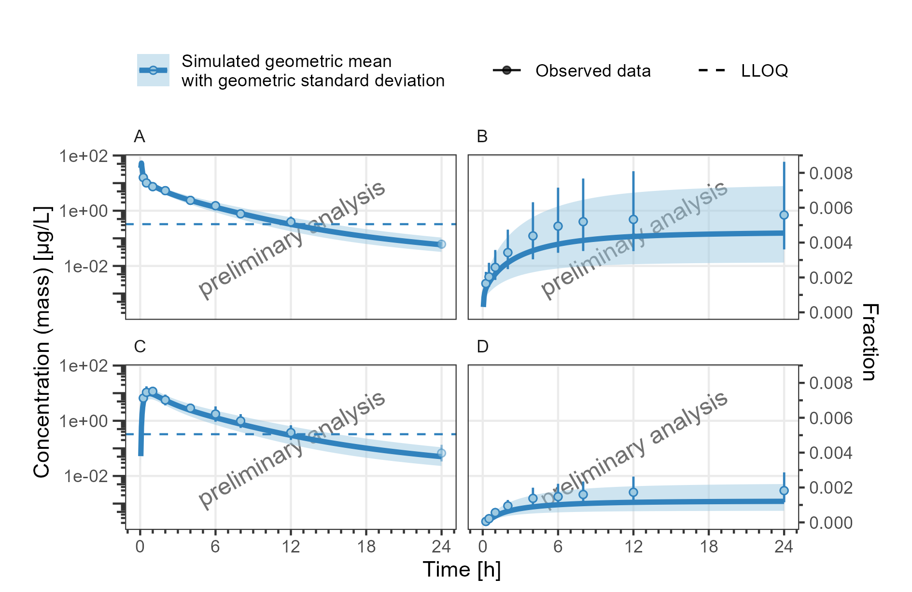

Observed data is displayed as geometric mean and geometric standard deviation  
**Figure 34: Concentration-time profiles for DrugX Plasma (A, C) and Fraction excreted to urine (B, D) for random population simulation of a 1mg 5min iv administration (A, B) and random population simulation of a 5mg oral administration (C, D) on a logarithmic y-scale. NA**

## 4) Adding Reference Populations

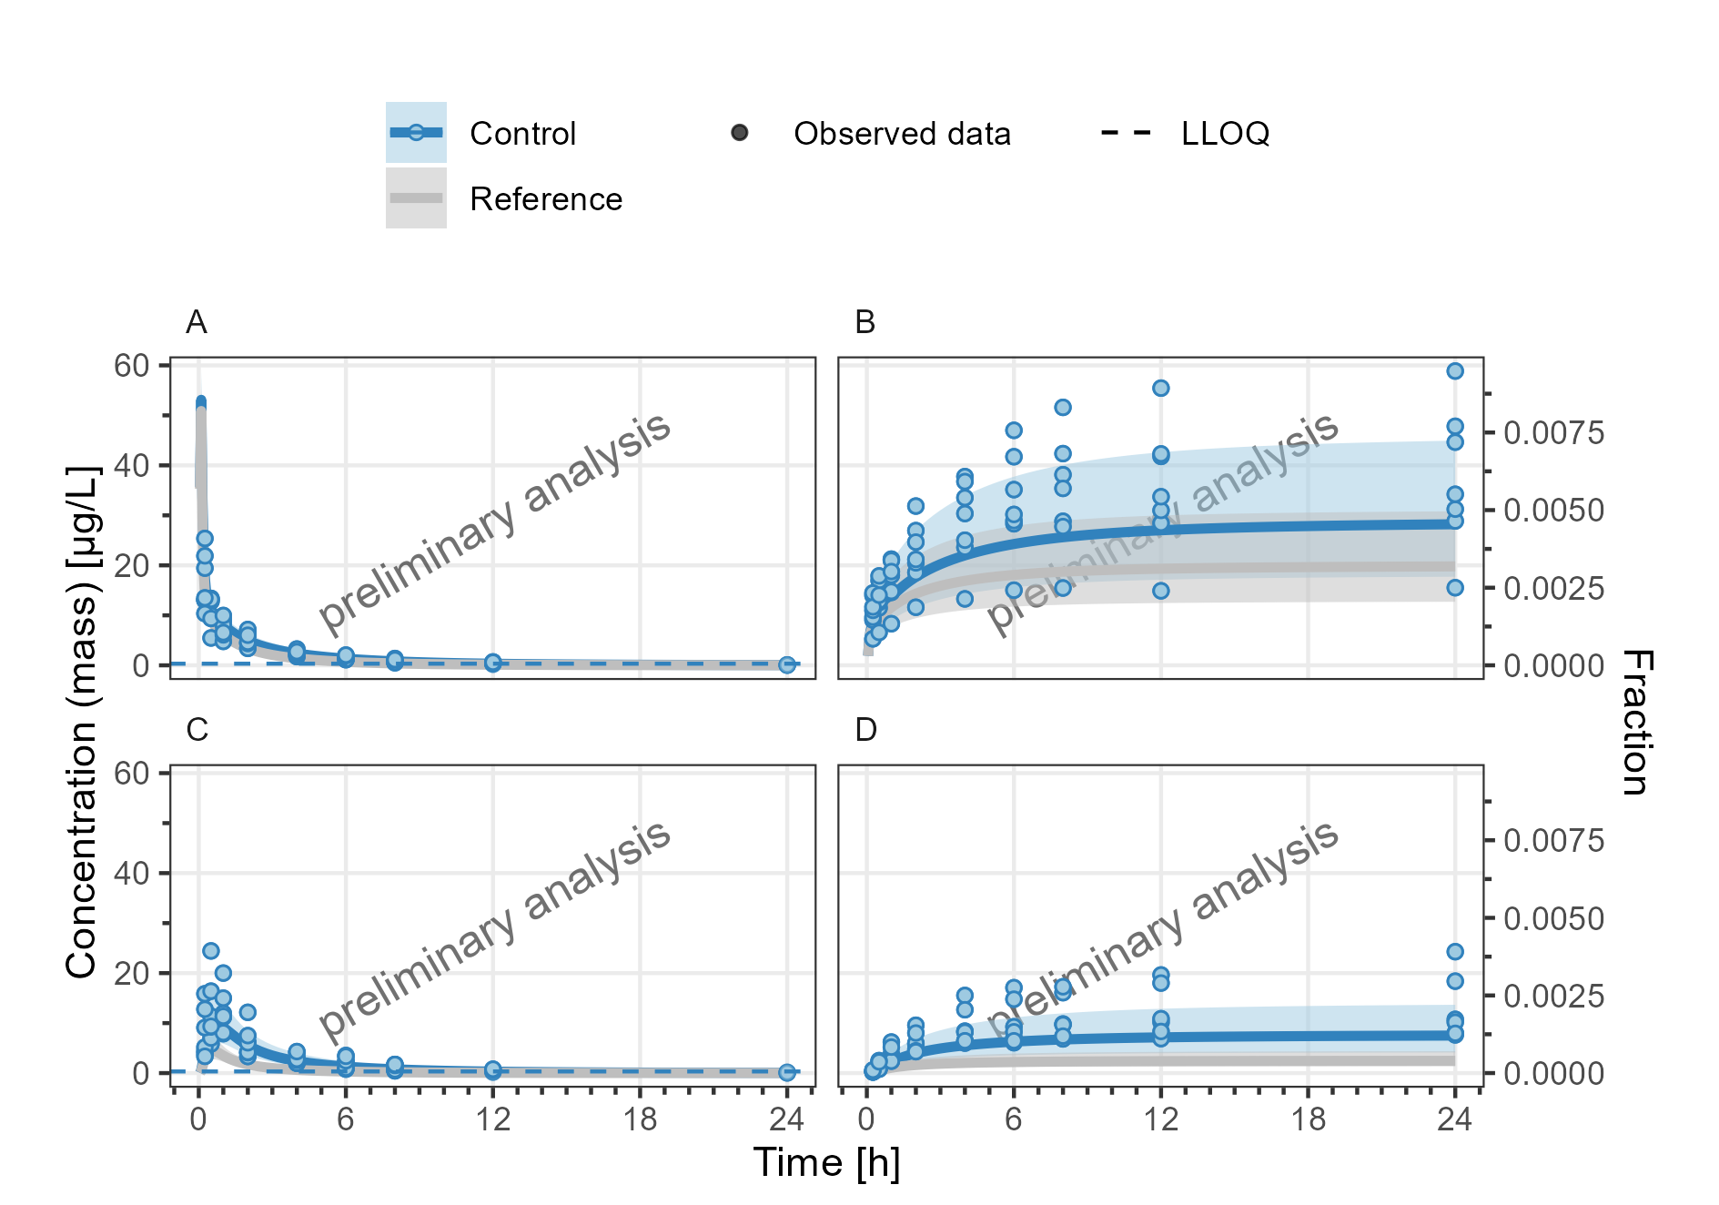

**Figure 35: Concentration-time profiles for DrugX Plasma (A, C) and Fraction excreted to urine (B, D) for random population simulation of a 1mg 5min iv administration (A, B) and random population simulation of a 5mg oral administration (C, D) on a linear y-scale. Reference population has doubled CYP3A4 liver ontogeny.**

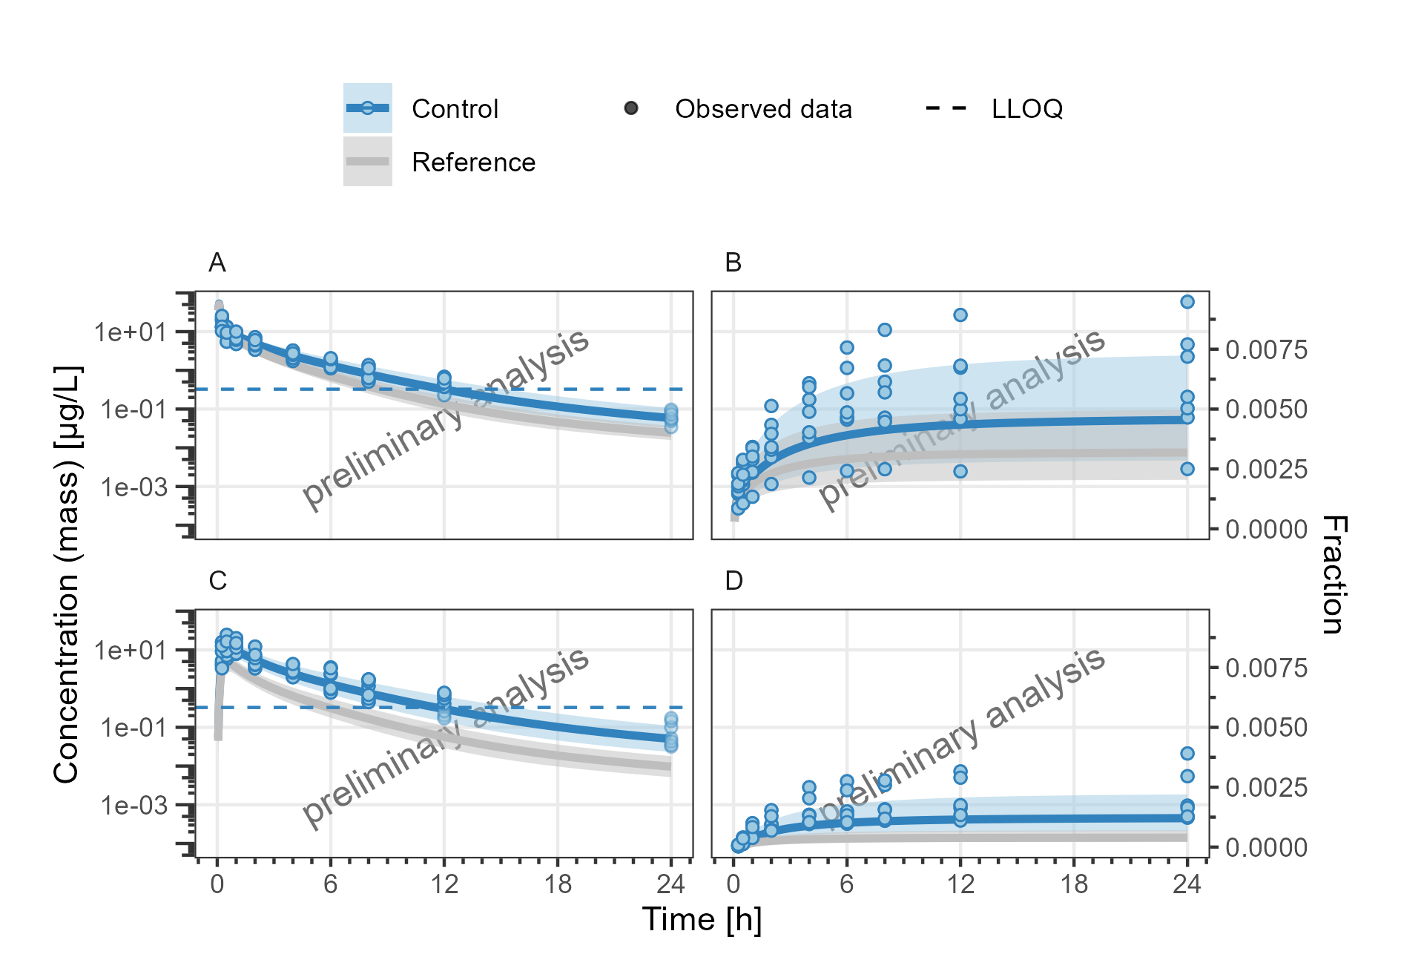

**Figure 36: Concentration-time profiles for DrugX Plasma (A, C) and Fraction excreted to urine (B, D) for random population simulation of a 1mg 5min iv administration (A, B) and random population simulation of a 5mg oral administration (C, D) on a logarithmic y-scale. Reference population has doubled CYP3A4 liver ontogeny.**



**Figure 37: Concentration-time profiles for DrugX Plasma (A, C) and Fraction excreted to urine (B, D) for random population simulation of a 1mg 5min iv administration (A, B) and random population simulation of a 5mg oral administration (C, D) on a linear y-scale. Zoom on the first dose Reference population has doubled CYP3A4 liver ontogeny.**



**Figure 38: Concentration-time profiles for DrugX Plasma (A, C) and Fraction excreted to urine (B, D) for random population simulation of a 1mg 5min iv administration (A, B) and random population simulation of a 5mg oral administration (C, D) on a logarithmic y-scale. Zoom on the first dose Reference population has doubled CYP3A4 liver ontogeny.**

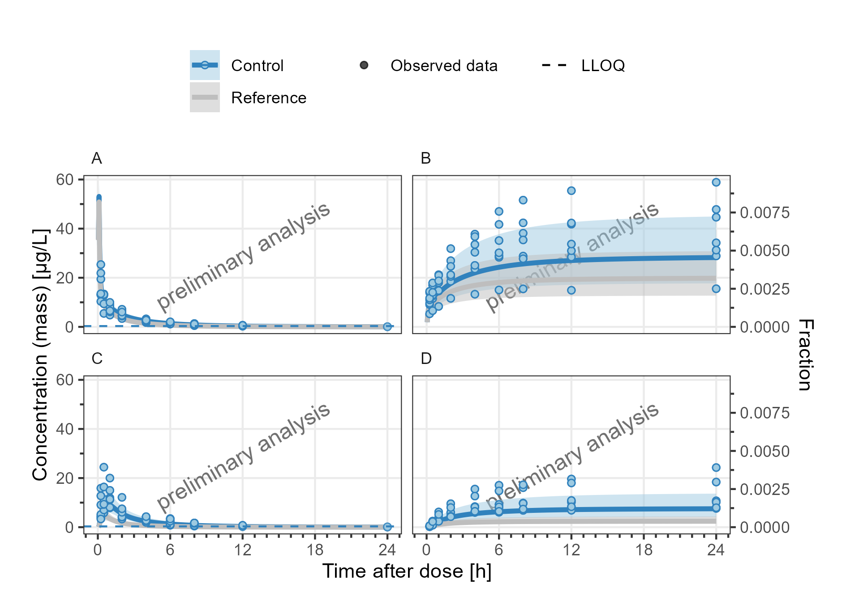

**Figure 39: Concentration-time profiles for DrugX Plasma (A, C) and Fraction excreted to urine (B, D) for random population simulation of a 1mg 5min iv administration (A, B) and random population simulation of a 5mg oral administration (C, D) on a linear y-scale. Zoom on steady state dose Reference population has doubled CYP3A4 liver ontogeny.**

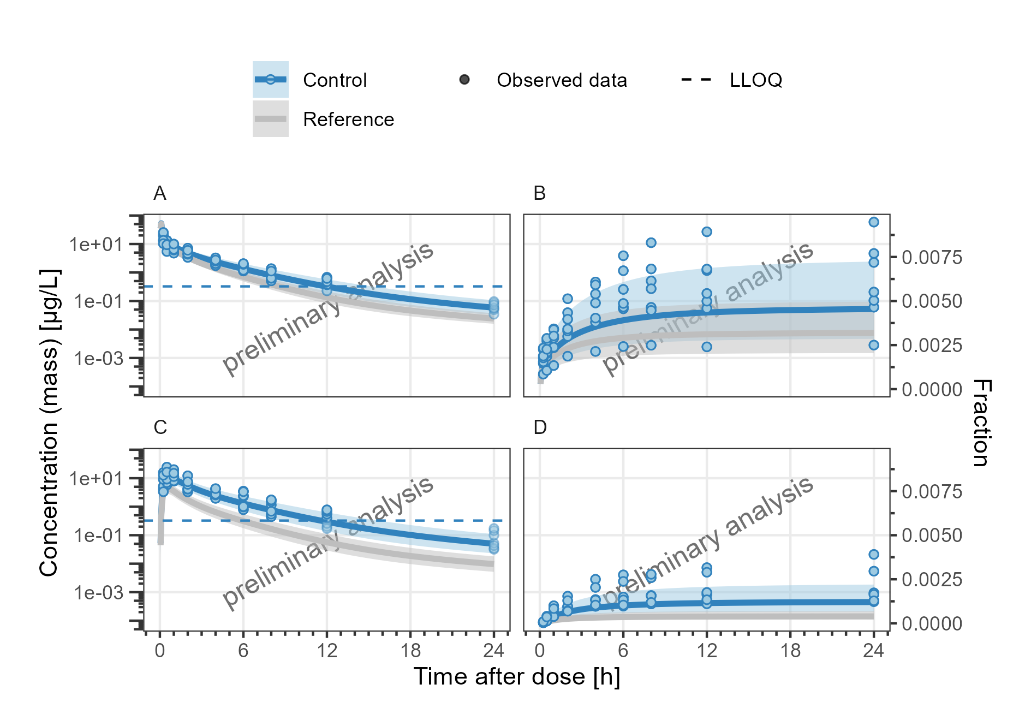

**Figure 40: Concentration-time profiles for DrugX Plasma (A, C) and Fraction excreted to urine (B, D) for random population simulation of a 1mg 5min iv administration (A, B) and random population simulation of a 5mg oral administration (C, D) on a logarithmic y-scale. Zoom on steady state dose Reference population has doubled CYP3A4 liver ontogeny.**

## 5) Adding Plots with different Time Ranges

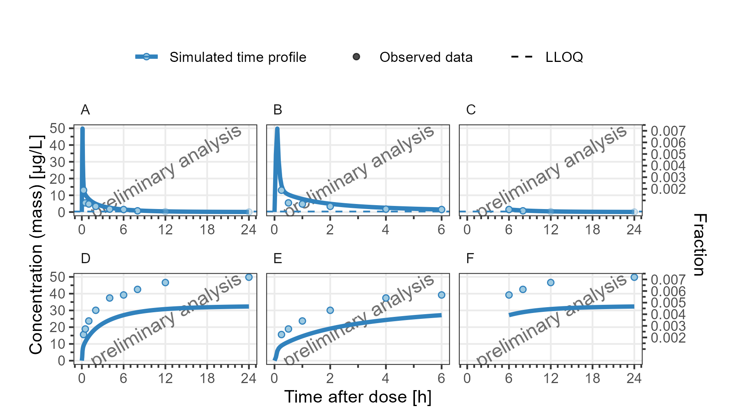

**Figure 41: Concentration-time profiles for DrugX Plasma (A, B, C) and Fraction excreted to urine (D, E, F) for individual 1 of study 000 on a linear y-scale. (A, D), Zoom on first 6 hours (B, E) and Zoom on time range 6 to 24 hours (C, F). DrugX was admistered as a 1mg Iv application with an infusion time of 5 minutes.**

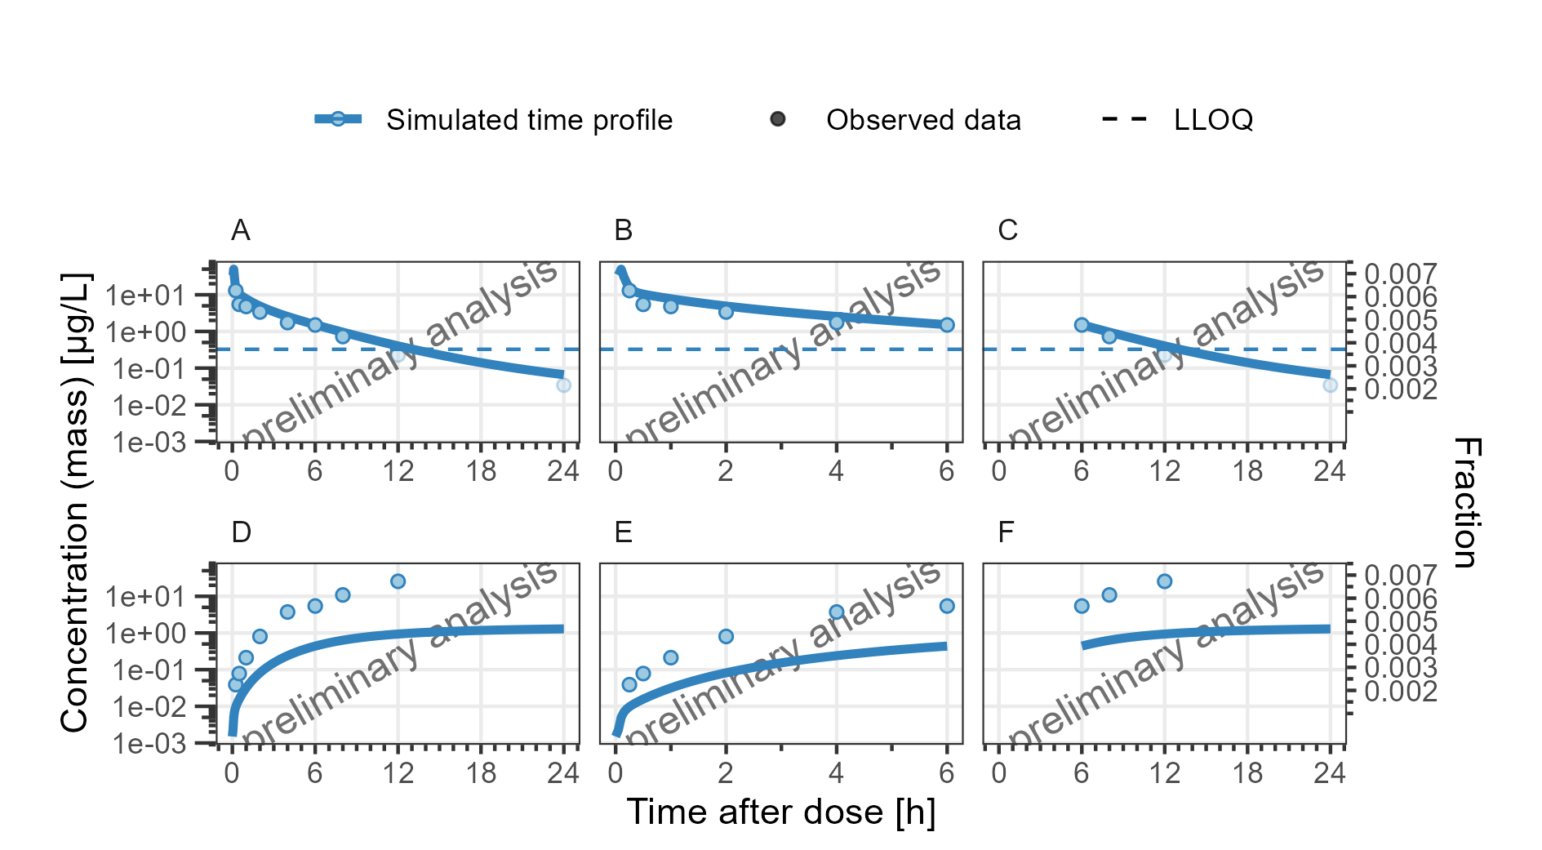

**Figure 42: Concentration-time profiles for DrugX Plasma (A, B, C) and Fraction excreted to urine (D, E, F) for individual 1 of study 000 on a logarithmic y-scale. (A, D), Zoom on first 6 hours (B, E) and Zoom on time range 6 to 24 hours (C, F). DrugX was admistered as a 1mg Iv application with an infusion time of 5 minutes.**